Concurrent Programming

# Java memory Model (JMM)

## Out Of Order Execution

We assume the program will run sequentially as the way it’s written.

But JVM / compiler/ OS / CPU will optimize the instruction order such that program semantics are same. So the output will be same but order may change.

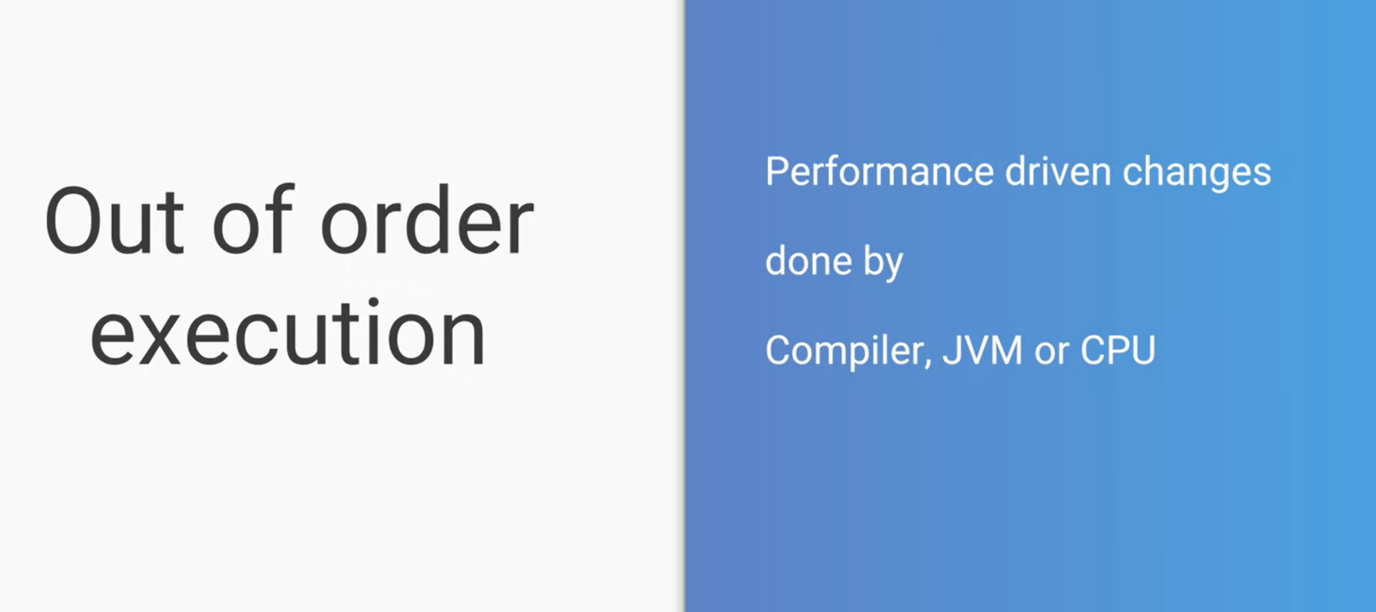

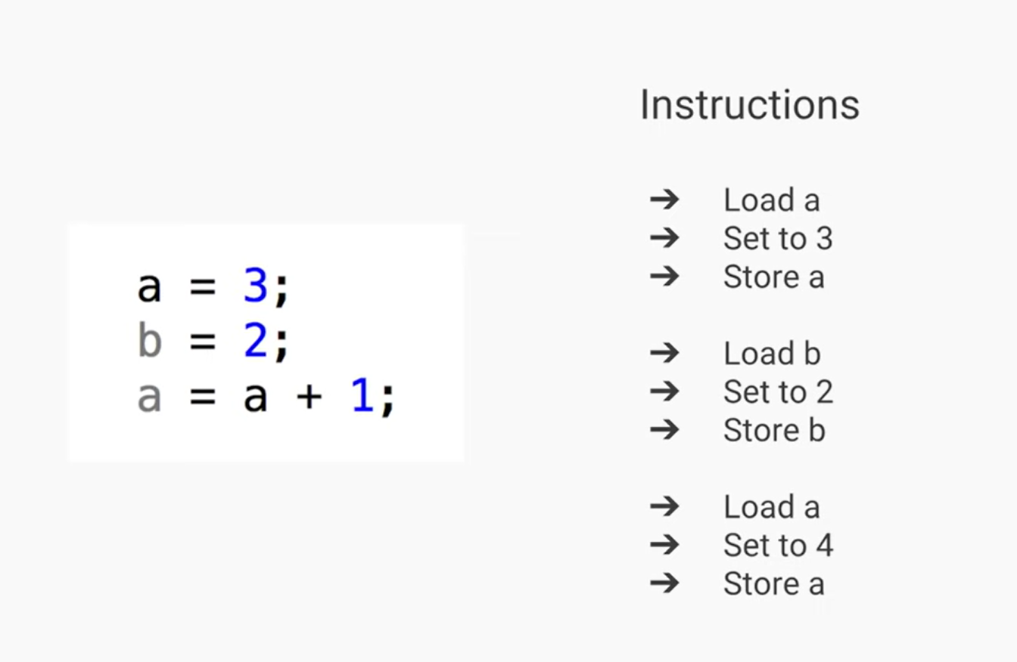

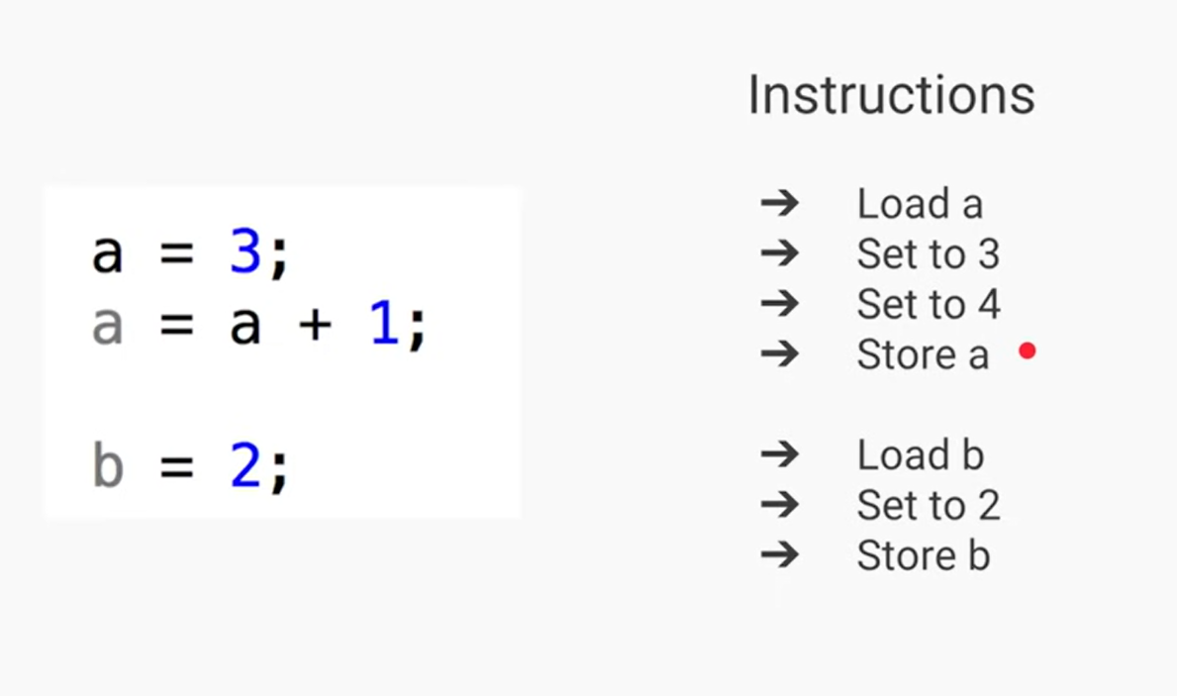

## Field Visibility

It is generally applicable in multithreaded environment.



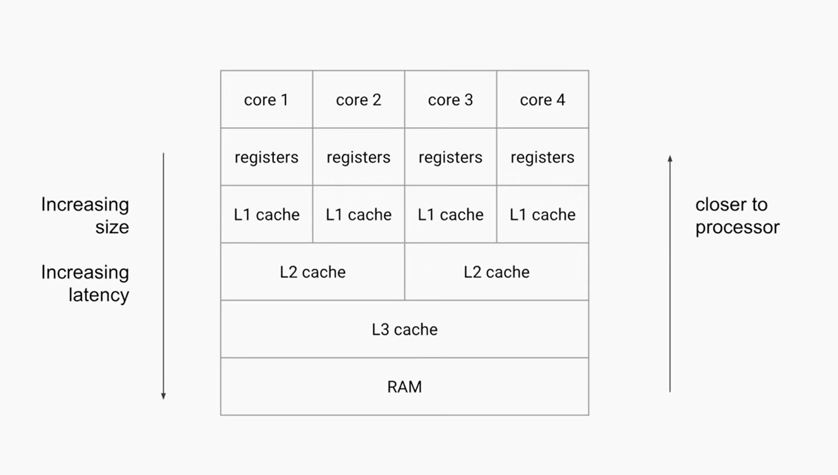

if you have a quad-core machine which of course means you have four cores code

each core generally has a set of registers. They are nothing but a memory area which is very small but it is within the core and that is why it is fastest to retrieve any value out of it or store value in it

then one layer further you have L1 cache which is again only a memory area set aside for each of the CORE

you have L2 cache which could be shared between two cores and then you have L3 cache and RAM which could be shared across four cores so in this case the farther the memory from the core of

course it will induce more latency but it will have more size that will be cheaper.

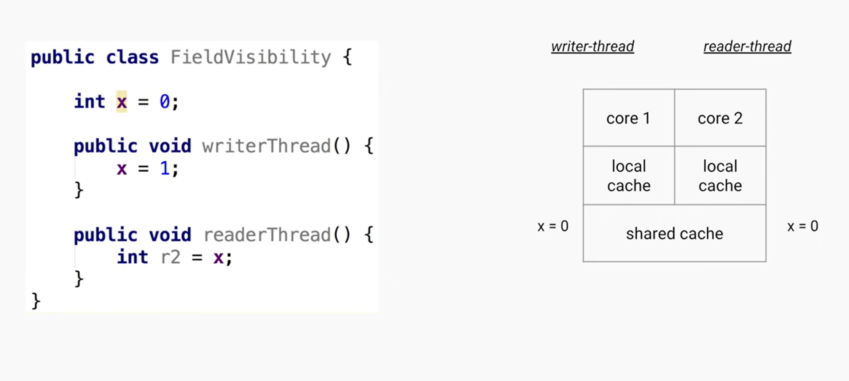

We are creating an instance of FieldVisibility and is accessed by 2 threads which are running parallely in core1 and core2 respectively.

Thread 1 (writer thread) will only call writerThread()

Thread 2 (reader thread) will only call readerThread()

So suppose thread Thread1 has called writerThread() and the value has been updated to 1, So this will be stored in its respective local cache, And it will might not be updated on the sharedCache, that’s why when we call readerThread() using thread 2, it might still show 0.

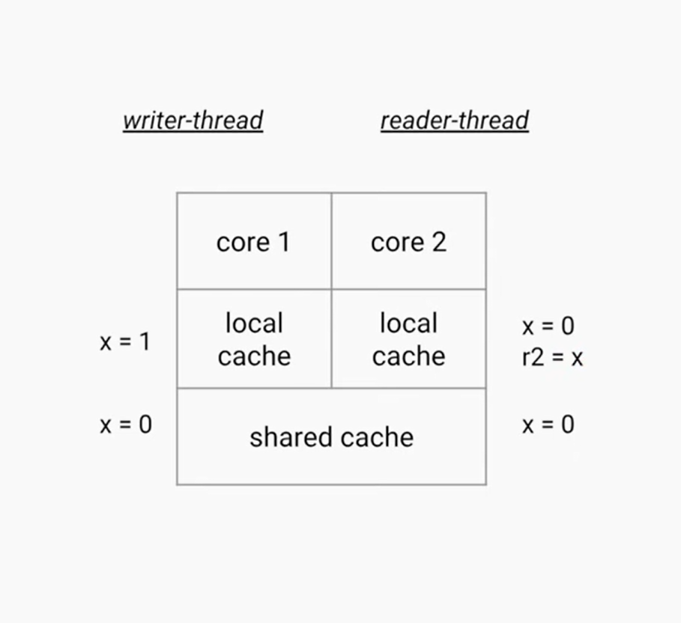

Java has a solution for this.

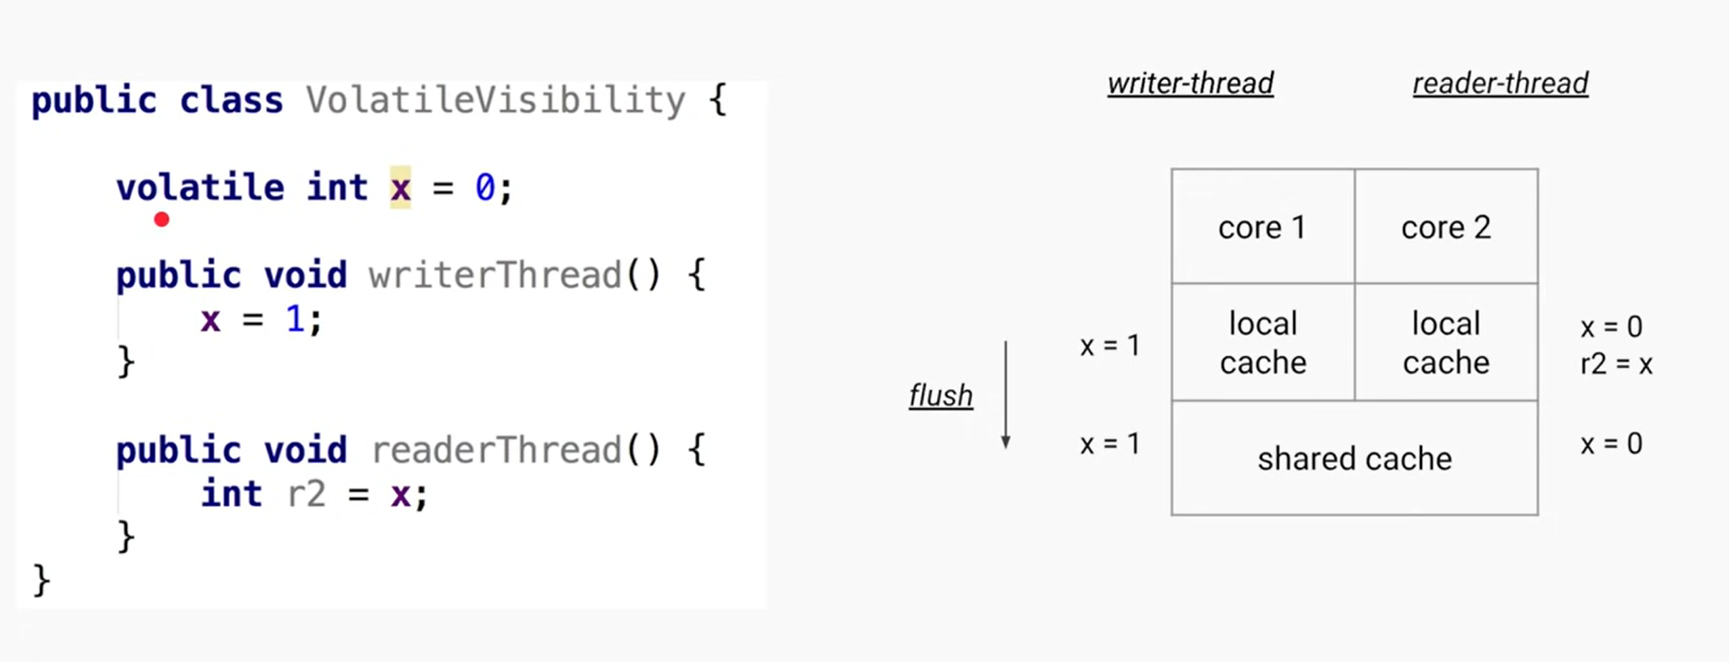

We can use volatile keyword and that will ensure the JVM will flush/push the value to Shared cache once its mutated.

So that when any other core tries to load that value it will always get the updated value so making this one small change of making the where the type of the variable is volatile ensures that the field visibility problem is solved.

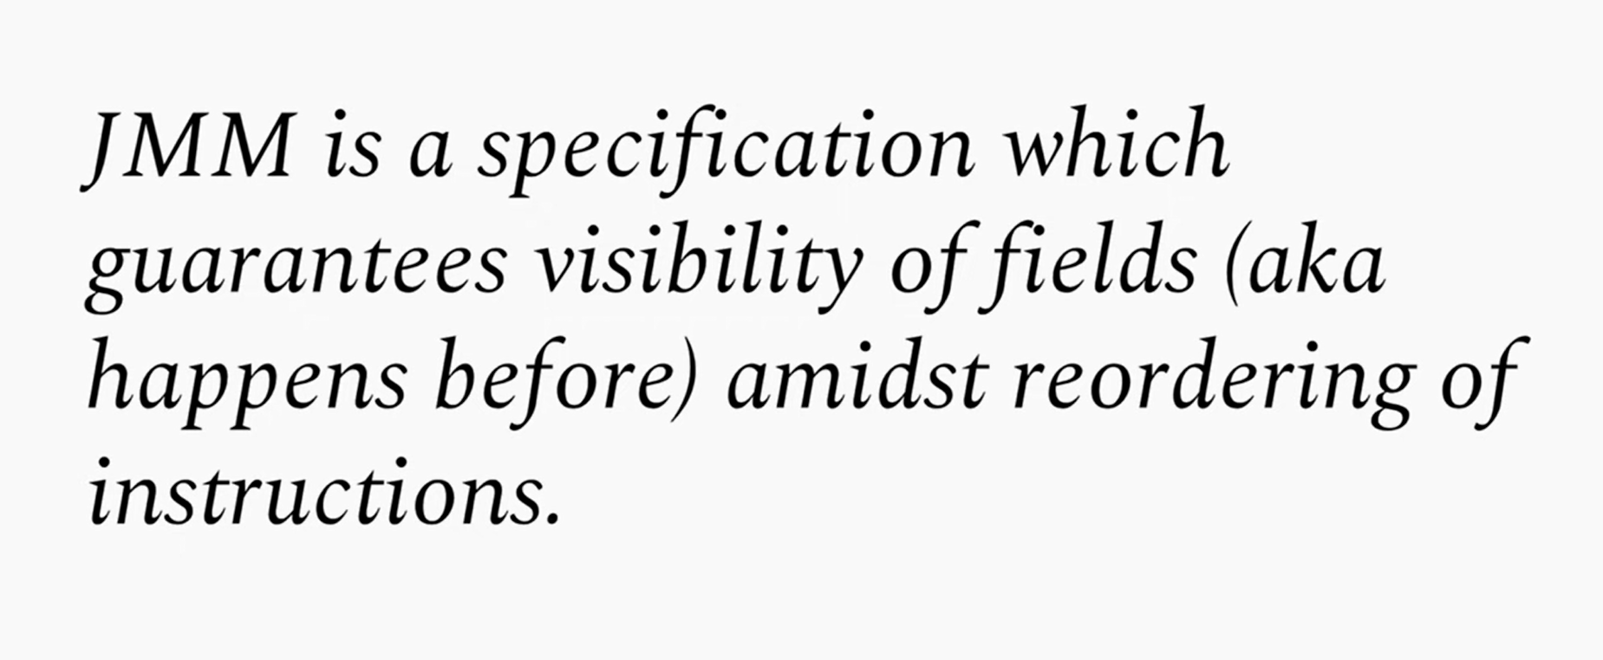

This makes JAVA JVM independent.

Java memory model enforces that all the JVM must implement these set of rules so that if you run a program on one JVM if you pick that program run on another JVM your program runs the same.

## Happens-before relationship

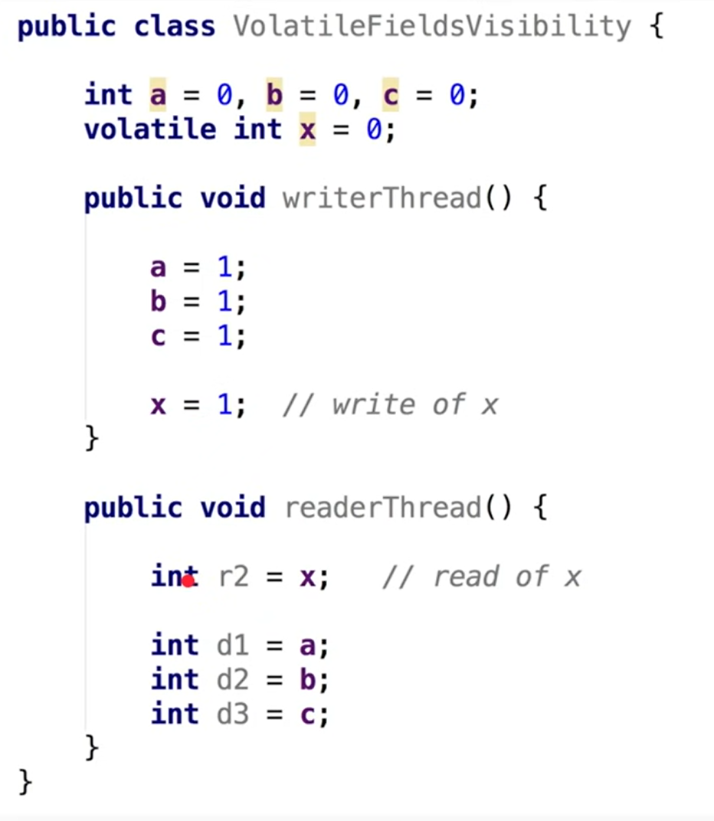

JMM also has some operation on final fields but that is a different case.

Java memory model ensures or there is a rule that any fields that are written to before you write X those values should be updated and visible to any other thread after it has read the value of x right so it says whatever has happened before this it should be visible after this and that is why it is called a happens before relationship in fact this is not just applicable to volatile.

This concept up happens before relationship and field visibility is also applicable to things like

* synchronized keyword
* synchronized method synchronous blocks
* locks lock operations some operations of
* the concurrent collections and some
* thread operations like join and start

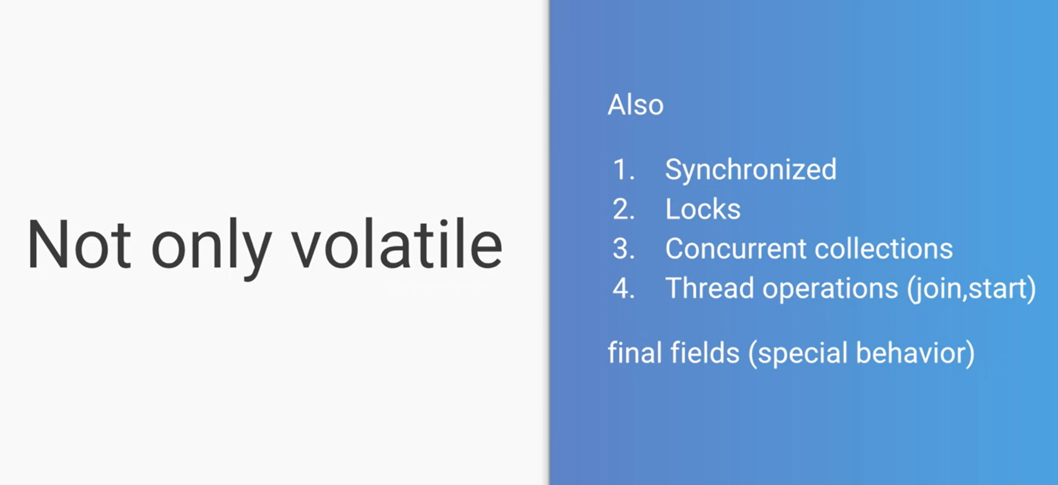

So JMM is still applicable when we use **synchronized** block. Only caveat is you have to synchronise the current instance or its should be applied on the same object, and that’s common for the shared thread.

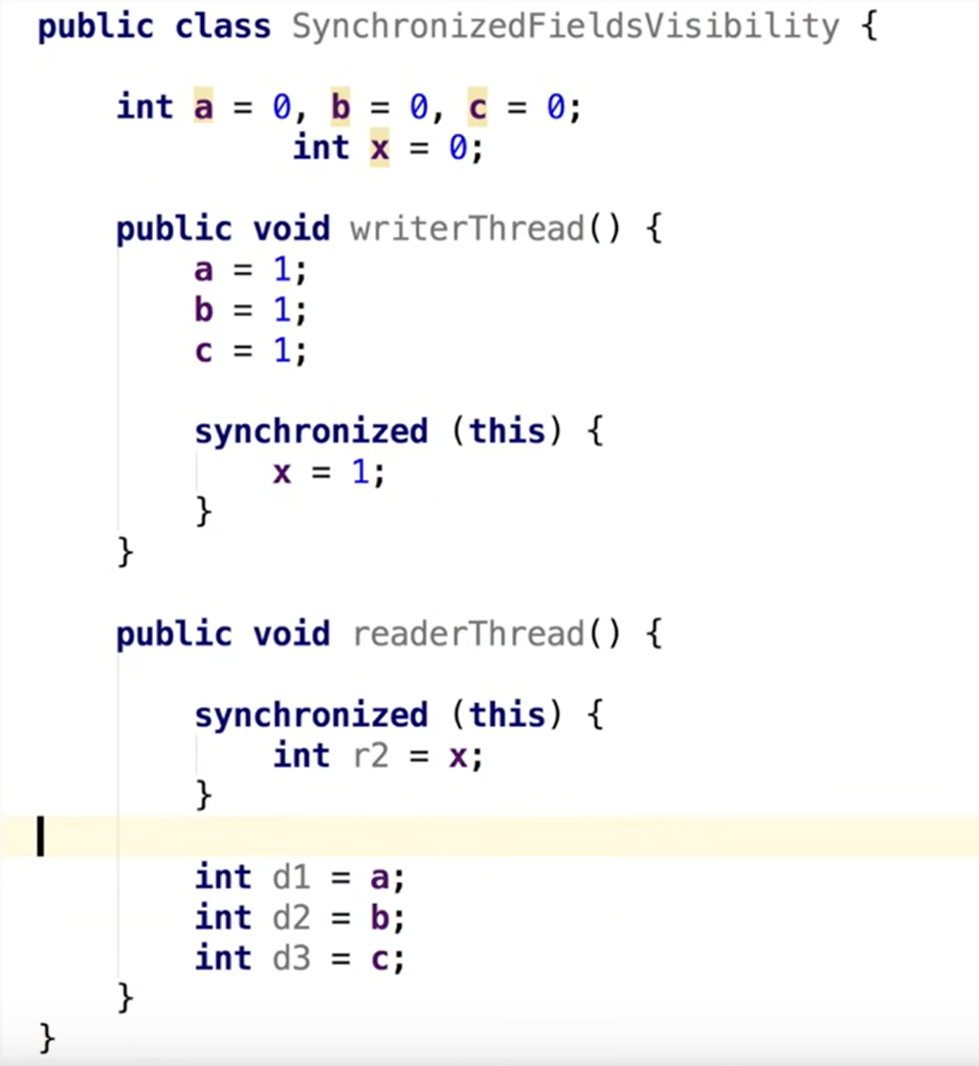

Synchronise in a better way

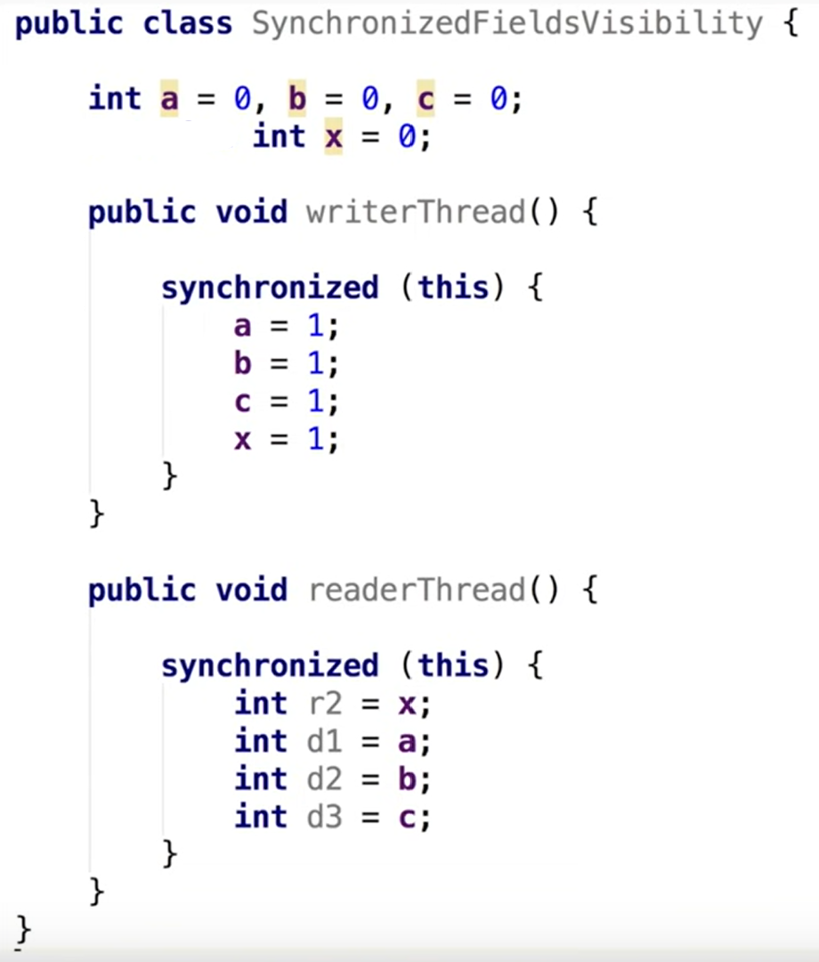

JMM via lock

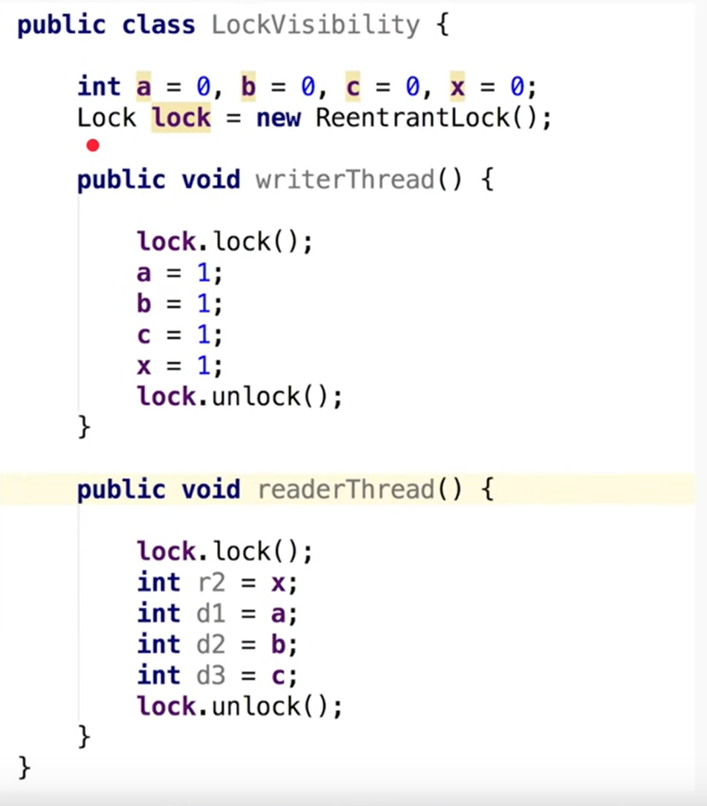

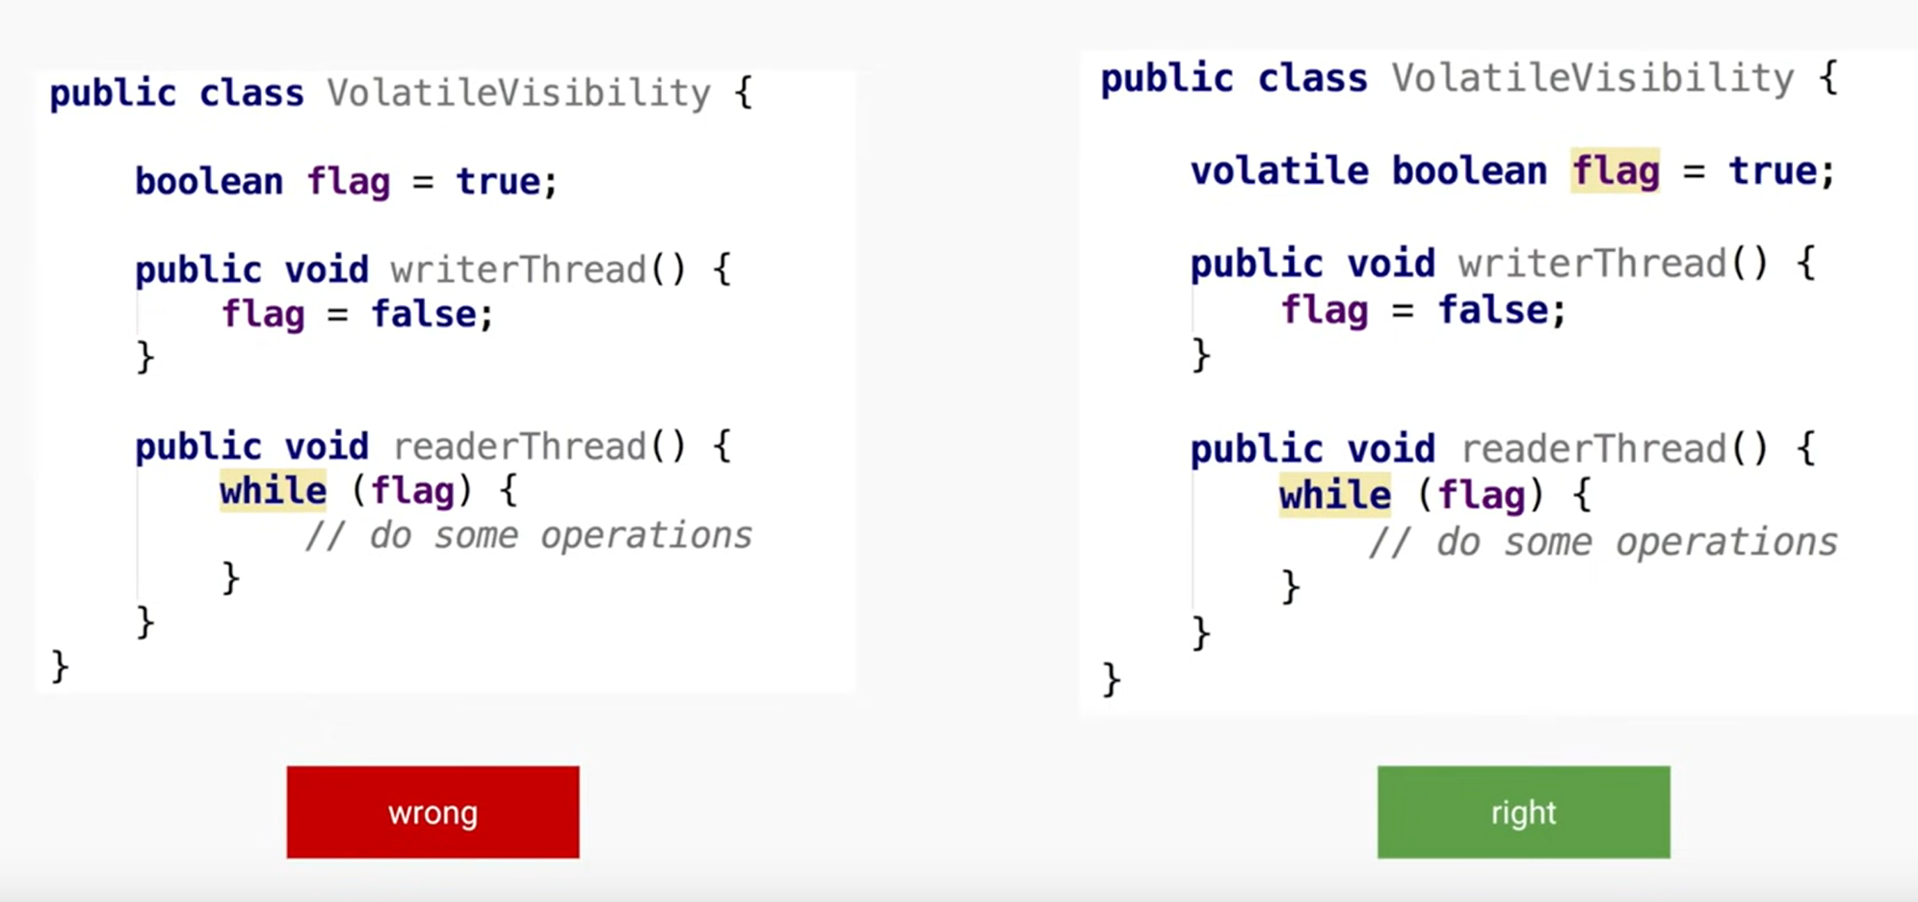

Figure Popular Interview Question

# Parallelism vs Concurrency

## Parallelism

In OS there is a component called scheduler, which is responsible to schedule the thread on to the CPU.

We are assuming I have 4core CPU

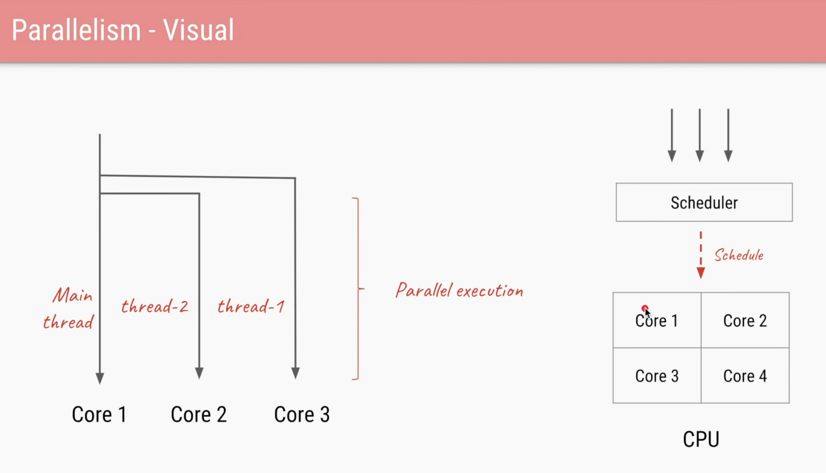



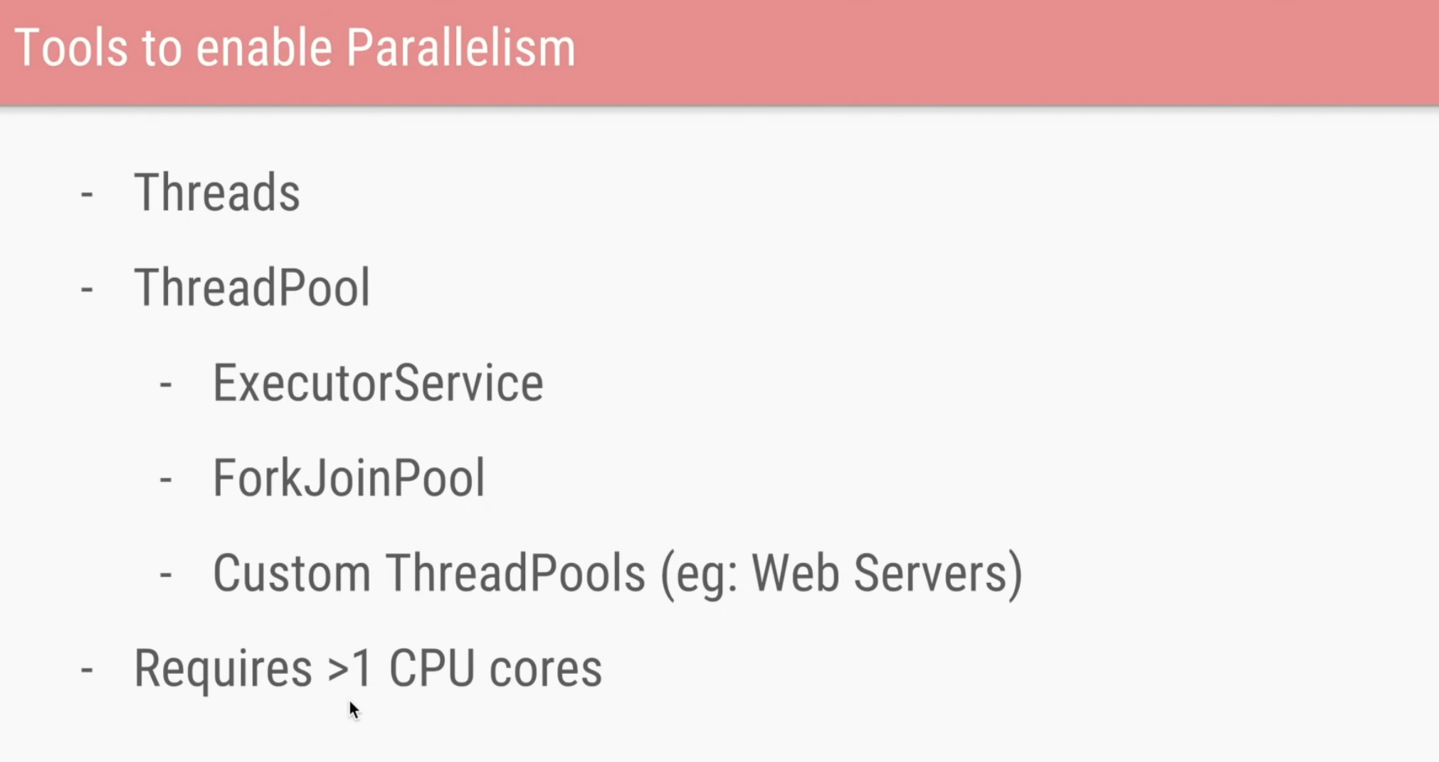

ForkJoinPool it’s a bit newer Thread pool and that also can be used to achieve parallelism.

The **ForkJoinPool** class is the centre of the fork/join framework, which is an implementation of the ExecutorService interface. ForkJoinPool class is an extension of the AbstractExecutorService class, and it implements the work-stealing algorithm (i.e., worker threads that run out of things to do can steal tasks from other threads that are still busy) of fork/join framework and can execute ForkJoinTask processes.

## Concurrency

Let’s assume we have only one core in the CPU.

In that case the threads will be handled via single core only, the only difference will be the shared CPU time for each thread.

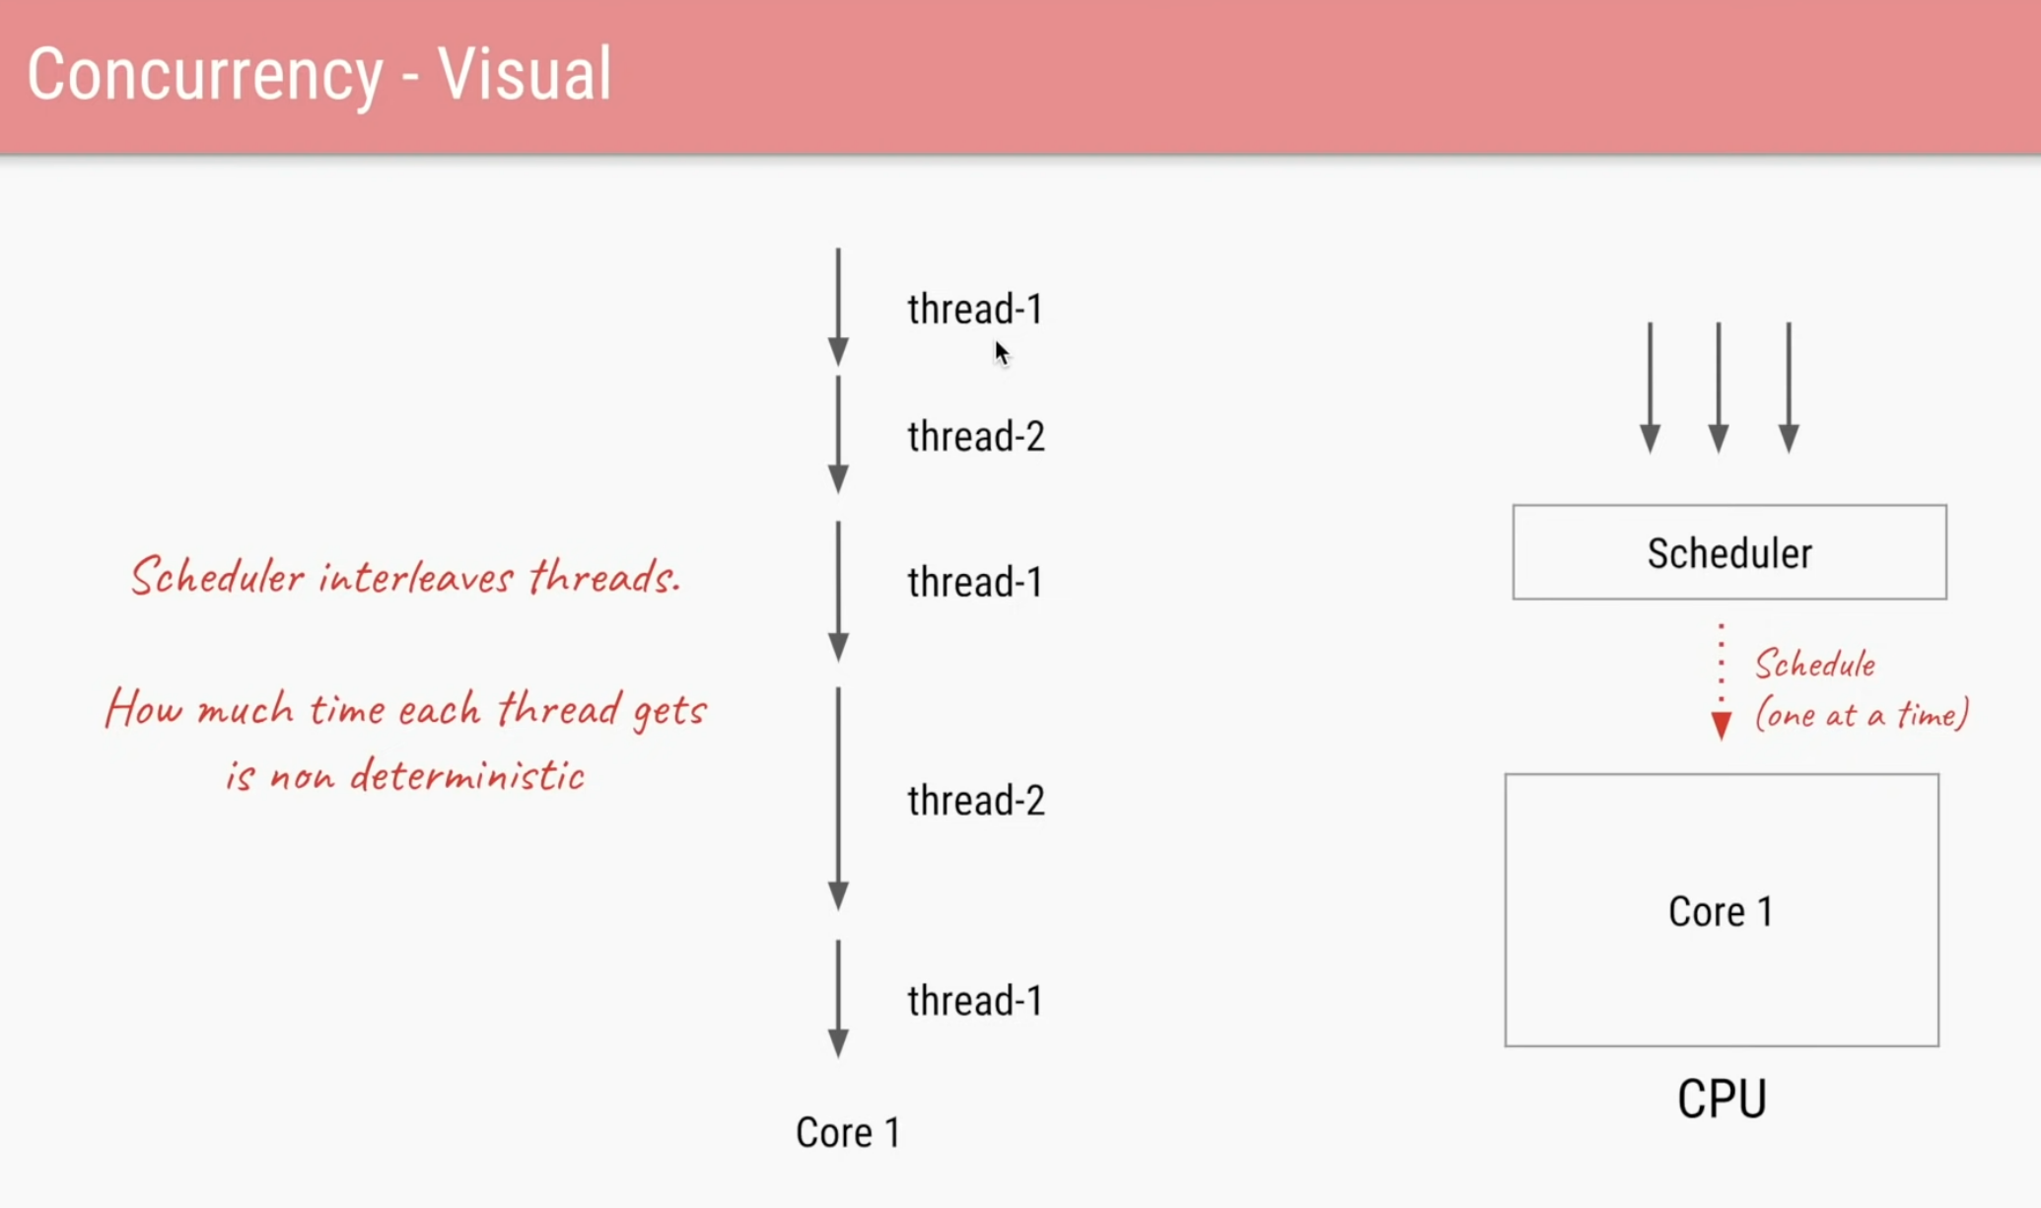

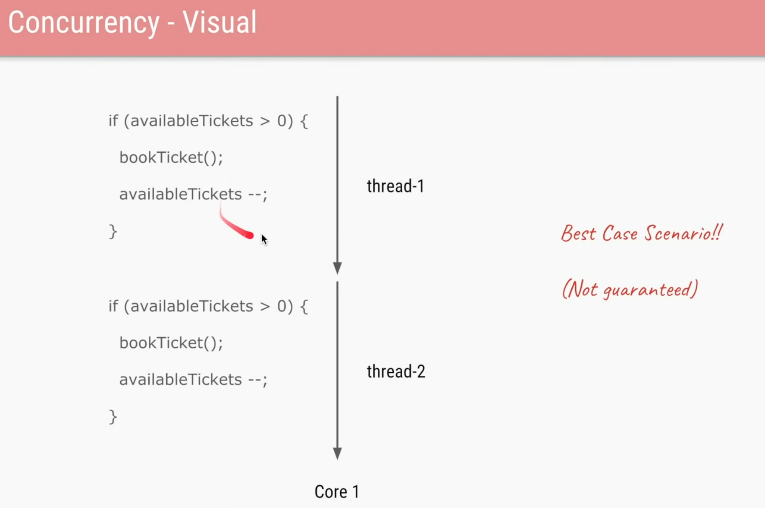

Figure : Best Case Scenario

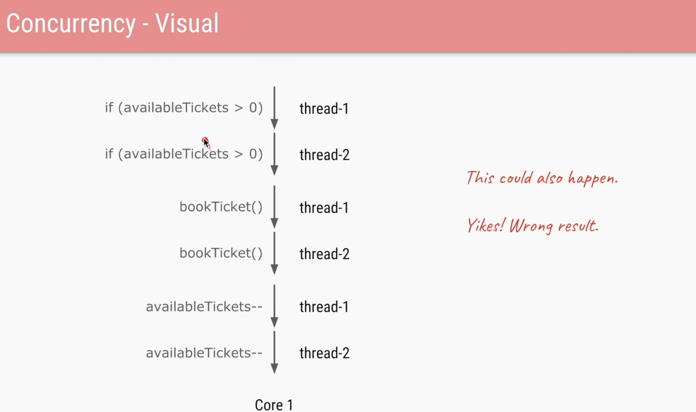

Figure : Wrong Case 1(Single Core) tickets will be booked even if ticket count is one

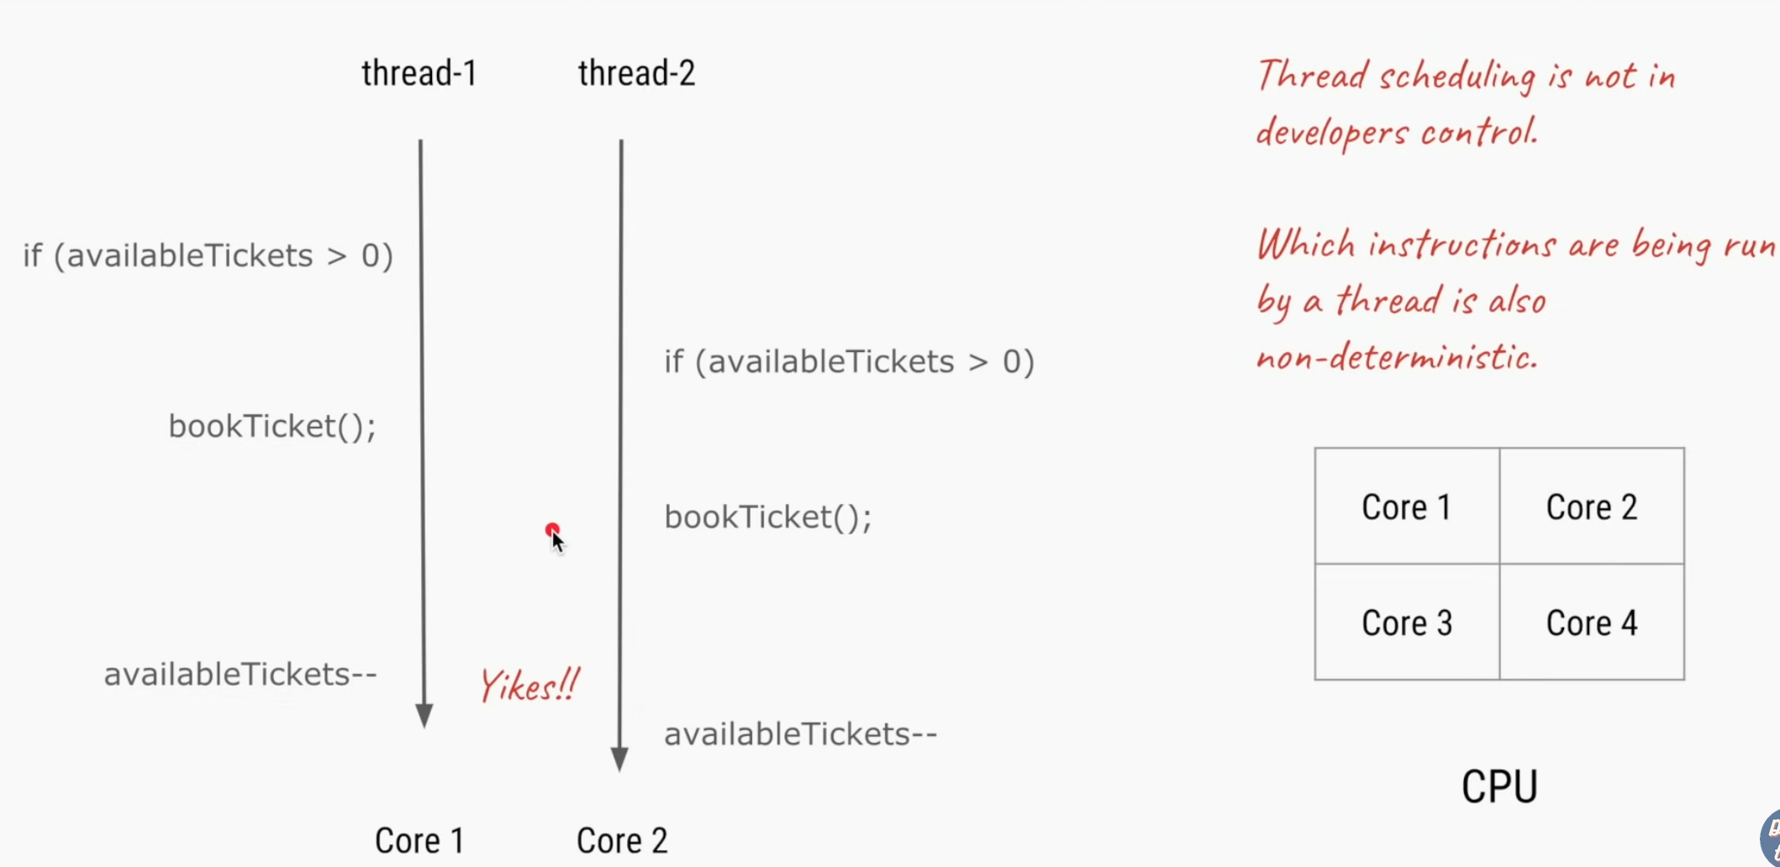

Same can happen for multiple cores, it’s possible that the two threads see the same shared attribute at same time and book ticket even if the ticket count is 1



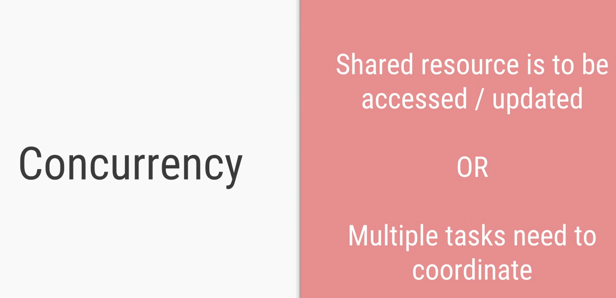

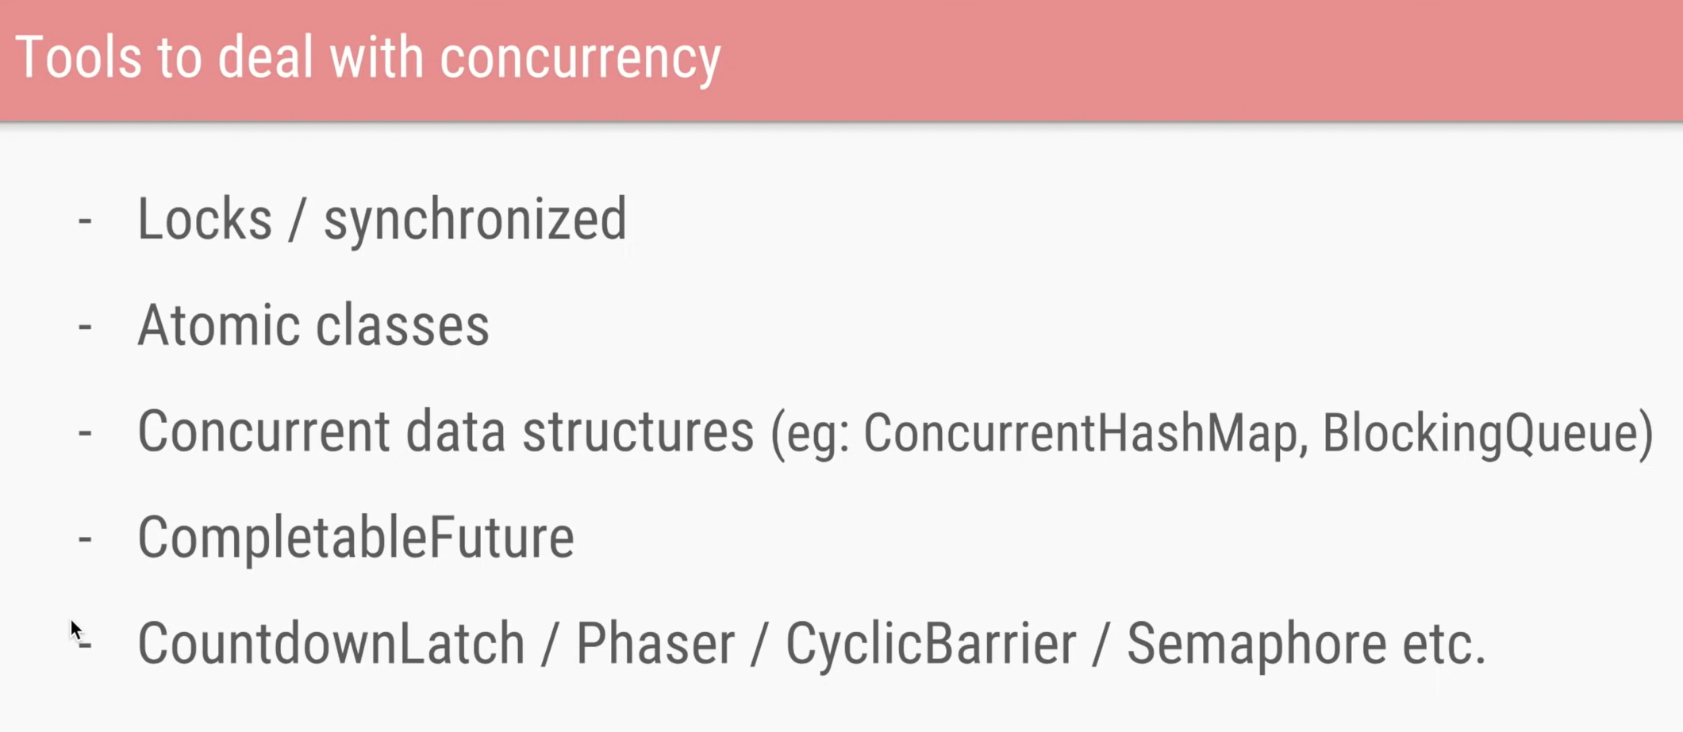

Parallelism is about doing a lot of things at once, concurrency is about dealing with a lot of things at once.

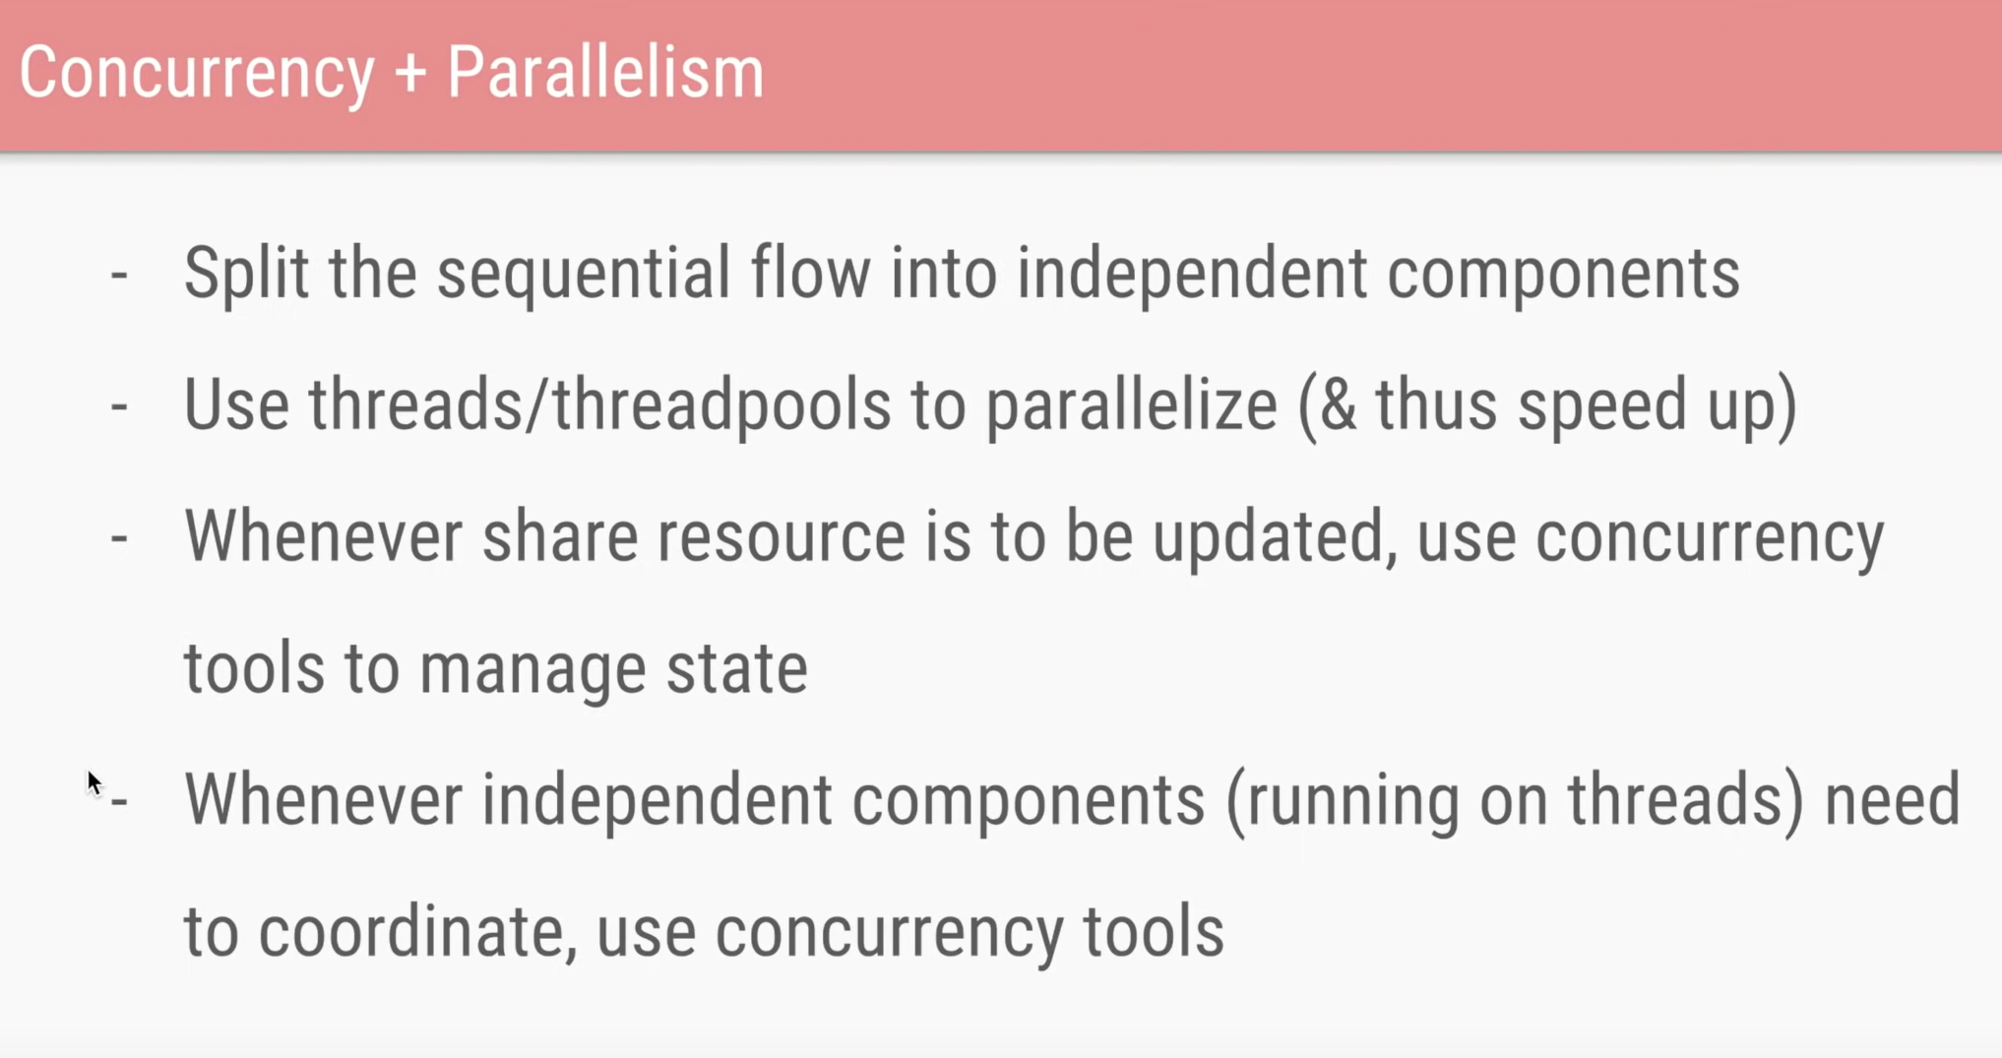

Thread interference and memory consistency errors can be avoided by ensuring the following two things-

1. Only one thread can read and write a shared variable at a time. When one thread is accessing a shared variable, other threads should wait until the first thread is done. This guarantees that the access to a shared variable is *Atomic*, and multiple threads do not interfere.
2. Whenever any thread modifies a shared variable, it automatically establishes a *happens-before* relationship with subsequent reads and writes of the shared variable by other threads. This guarantees that changes done by one thread are visible to others.

### Thread Interference Errors (Race Conditions)

Consider the following Counter class which contains an increment() method that increments the count by one, each time it is invoked -

class Counter {

int count = 0;

public void increment() {

count = count + 1;

}

public int getCount() {

return count;

}

}

Now, Let’s assume that several threads try to increment the count by calling the increment() method simultaneously -

Just run the program and see the output for yourself. Instead of producing the final count of 1000, it gives inconsistent result each time it is run. I ran the above program three times on my computer, and the output was 992, 996 and 993.

**Let’s dig deeper into the program and understand why the program’s output is inconsistent -**

When a thread executes the increment() method, following three steps are performed :

1. Retrieve the current value of count
2. Increment the retrieved value by 1
3. Store the incremented value back in count

Now let’s assume that two threads - ThreadA and ThreadB, execute these operations in the following order -

1. **ThreadA** : Retrieve count, initial value = 0
2. **ThreadB** : Retrieve count, initial value = 0
3. **ThreadA** : Increment retrieved value, result = 1
4. **ThreadB** : Increment retrieved value, result = 1
5. **ThreadA** : Store the incremented value, count is now 1
6. **ThreadB** : Store the incremented value, count is now 1

Both the threads try to increment the count by one, but the final result is 1 instead of 2 because the operations executed by the threads interleave with each other. In the above case, the update done by ThreadA is lost.

The above order of execution is just one possibility. There can be many such orders in which these operations can execute making the program’s output inconsistent.

When multiple threads try to read and write a shared variable concurrently, and these read and write operations overlap in execution, then the final outcome depends on the order in which the reads and writes take place, which is unpredictable. This phenomenon is called [Race condition](https://en.wikipedia.org/wiki/Race_condition).

The section of the code where a shared variable is accessed is called [Critical Section](https://en.wikipedia.org/wiki/Critical_section).

Thread interference errors can be avoided by synchronizing access to shared variables. We’ll learn about synchronization in the next section.

Let’s first look at the second kind of error that occurs in multithreaded programs - Memory Consistency Errors.

#### Synchronize keyword

Luckily, Java has a synchronized keyword using which you can synchronize access to any shared resource, thereby avoiding both kinds of errors.

We use Java’s synchronized keyword on increment() method to prevent multiple threads from accessing it concurrently –

package com.sumanshekhar.java.advance.multithreading_2;

import java.util.concurrent.ExecutorService;

import java.util.concurrent.Executors;

import java.util.concurrent.TimeUnit;

public class RaceConditionExample {

static class Counter {

int count = 0;

public void increment() {

count = count + 1;

}

public int getCount() {

return count;

}

}

static class SynchronizedCounter {

private int count = 0;

// Synchronized Method

public synchronized void increment() {

count = count + 1;

}

public int getCount() {

return count;

}

}

public static void main(String[] args) throws InterruptedException {

ExecutorService executorService = Executors.newFixedThreadPool(10);

// Counter counter = new Counter();

SynchronizedCounter counter = new SynchronizedCounter();

for(int i = 0; i < 1000; i++) {

executorService.submit(() -> counter.increment());

}

executorService.shutdown();

executorService.awaitTermination(60, TimeUnit.SECONDS);

System.out.println("Final count is : " + counter.getCount());

}

}

If you run the above program, it will produce the desired output of 1000. No race conditions occur and the final output is always consistent. **The synchronized keyword makes sure that only one thread can enter the increment() method at one time.**

Note that the concept of Synchronization is always bound to an object. In the above case, multiple invocations of increment() method on the same instance of SynchonizedCounter leads to a race condition. And we’re guarding against that using the synchronized keyword. But threads can safely call increment() method on different instances of SynchronizedCounter at the same time, and that will not result in a race condition.

In case of static methods, synchronization is associated with the [Class](https://docs.oracle.com/javase/8/docs/api/java/lang/Class.html) object.

#### **Synchronized Blocks**

Java internally uses a so-called intrinsic lock or monitor lock to manage thread synchronization. Every object has an intrinsic lock associated with it.

When a thread calls a synchronized method on an object, it automatically acquires the intrinsic lock for that object and releases it when the method exits. The lock release occurs even if the method throws an exception.

In case of static methods, the thread acquires the intrinsic lock for the Class object associated with the class, which is different from the intrinsic lock for any instance of the class.

synchronized keyword can also be used as a block statement, but unlike synchronized method, synchronized statements must specify the object that provides the intrinsic lock -

public void increment() {

// Synchronized Block -

// Acquire Lock

synchronized (this) {

count = count + 1;

}

// Release Lock

}

When a thread acquires the intrinsic lock on an object, other threads must wait until the lock is released. However, the thread that currently owns the lock can acquire it multiple times without any problem.

The idea of allowing a thread to acquire the same lock more than once is called Reentrant Synchronization.

### Memory Consistency Errors

Memory inconsistency errors occur when different threads have inconsistent views of the same data. This happens when one thread updates some shared data, but this update is not propagated to other threads, and they end up using the old data.

**Why does this happen?** Well, there can be many reasons for this. The compiler does several optimizations to your program to improve performance. It might also reorder instructions in order to optimize performance. Processors also try to optimize things, for instance, a processor might read the current value of a variable from a temporary register (which contains the last read value of the variable), instead of main memory (which has the latest value of the variable).

Consider the following example which demonstrates Memory Consistency Error in action -

public class MemoryConsistencyErrorExample {

private static boolean sayHello = false;

public static void main(String[] args) throws InterruptedException {

Thread thread = new Thread(() -> {

while(!sayHello) {

}

System.out.println("Hello World!");

while(sayHello) {

}

System.out.println("Good Bye!");

});

thread.start();

Thread.sleep(1000);

System.out.println("Say Hello..");

sayHello = true;

Thread.sleep(1000);

System.out.println("Say Bye..");

sayHello = false;

}

}

In ideal scenario, the above program should -

1. Wait for one second and then print Hello World! after sayHello becomes true.
2. Wait for one more second and then print Good Bye! after sayHello becomes false.

# Ideal Output

Say Hello..

Hello World!

Say Bye..

Good Bye!

But do we get the desired output after running the above program? Well, If you run the program, you will see the following output -

# Actual Output

Say Hello..

Say Bye..

Also, the program doesn’t even terminate.

Wait. What? How is that possible?

Yes! That is what Memory Consistency Error is. The first thread is unaware of the changes done by the main thread to the sayHello variable.

You can use volatile keyword to avoid memory consistency errors. We’ll learn more about volatile Keyword shortly.

#### Volatile Keyword

Volatile keyword is used to avoid memory consistency errors in multithreaded programs. It tells the compiler to avoid doing any optimizations to the variable. If you mark a variable as volatile, the compiler will not optimize or reorder instructions around that variable.

Also, The variable’s value will always be read from the main memory instead of temporary registers.

Following is the same MemoryConsistencyError example that we saw in the previous section, except that, this time we have marked sayHello variable with volatile keyword.

public class VolatileKeywordExample {

private static volatile boolean sayHello = false;

public static void main(String[] args) throws InterruptedException {

Thread thread = new Thread(() -> {

while(!sayHello) {

}

System.out.println("Hello World!");

while(sayHello) {

}

System.out.println("Good Bye!");

});

thread.start();

Thread.sleep(1000);

System.out.println("Say Hello..");

sayHello = true;

Thread.sleep(1000);

System.out.println("Say Bye..");

sayHello = false;

}

}

Running the above program produces the desired output -

# Output

Say Hello..

Hello World!

Say Bye..

Good Bye!

<https://www.callicoder.com/java-concurrency-issues-and-thread-synchronization/>

# Volatile vs Atomic Integer

## Visibility Problem – ***volatile***

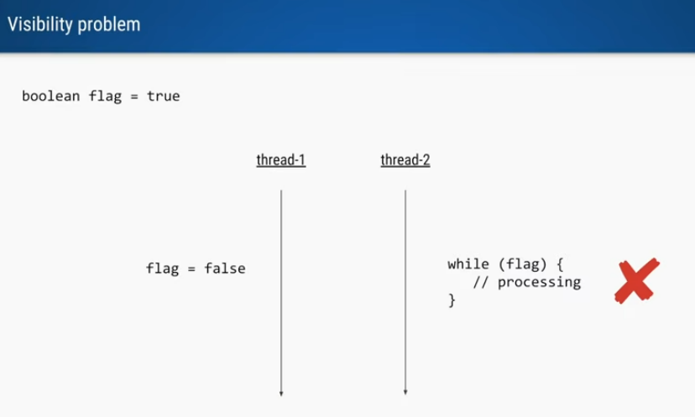

Say we have a shared variable flag= **true**, we are trying to change flag to **false**

Thinking that this will stop the infinite while loop in thread-2.

But according to JMM, this will not happen.

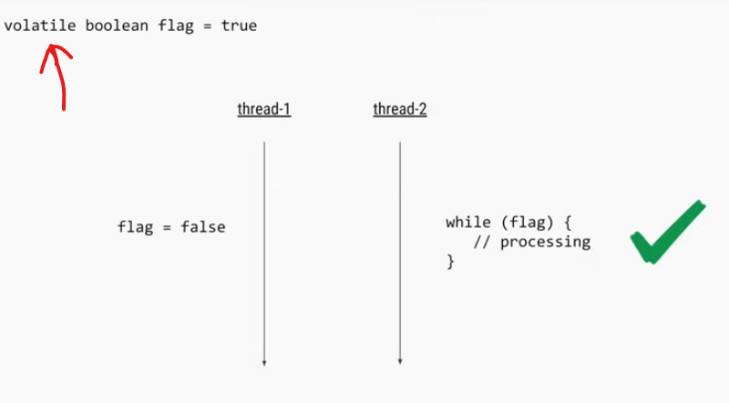

Using the **volatile** keyword, we can solve this visibility problem.

## Synchronization Problem – synchronize/ AtomicInteger

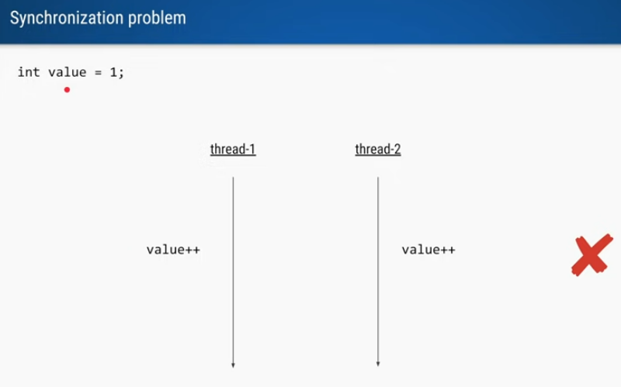

We are expecting to increment to 2 and then 3

Whenever the two thread runs we can have two case its fine.

Here even if we use volatile, it may be erroneous.

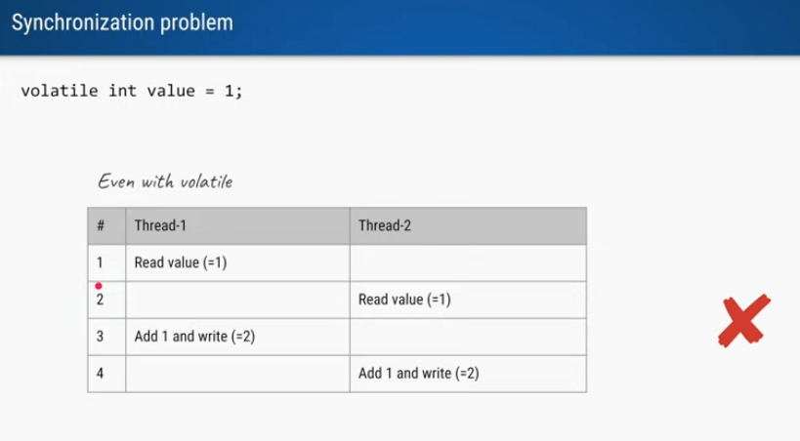

So, it is not an atomic operation it is a compounded operation.

So, it the above scenario, its probable that both threads will update to 2.

We can have ***synchronization*** to solve this issue.

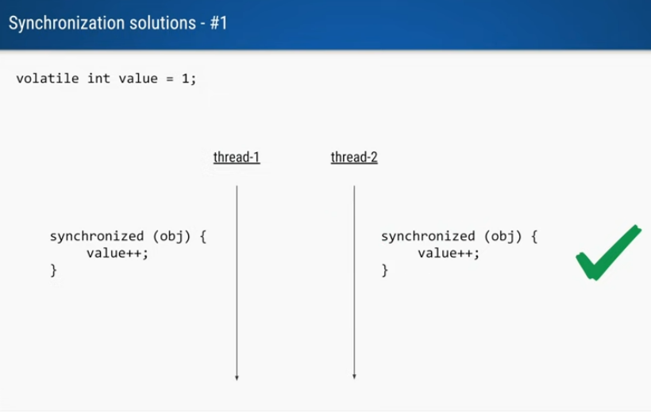

Figure : Solution One

While Synchronization only one thread will be allowed for compound operation, at the block ends, then the next threads can execute. The order may differ and it’s okay.

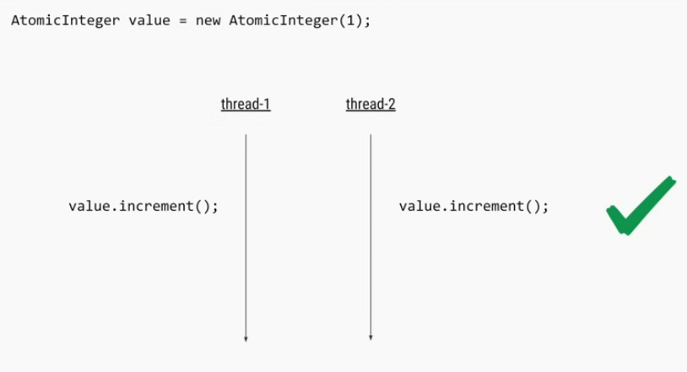

Figure : Via Atomic Operation

AtomicInteger ensures the operation is done atomically even there is no synchronization.

The method it has does the compound operation for us atomically.

JVM will take care now that this should be handled atomically.

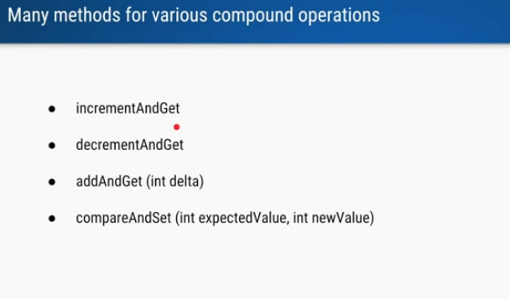

Figure : Few Compounds operation of Atomic Integer

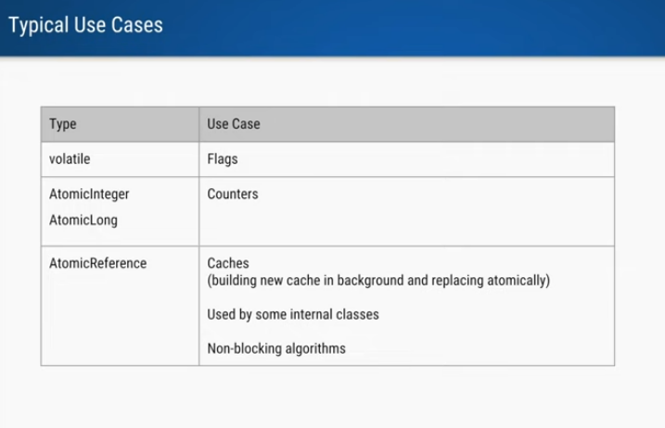

Figure : Use case

# ThreadLocal

## Case 1: 2 Thread 2 Task

**package com.sumanshekhar.java.advance.multithreading.multithreading_by_defog.threadlocal;  
  
import java.text.SimpleDateFormat;  
import java.util.Date;  
  
public class UserService {  
  
 public static void main(String[] args) {  
  
  
 new Thread(() -> {  
 String s = new UserService().birthDate(2);  
 System.out.println(Thread.currentThread() + s);  
 }).start();**

**}  
  
 public String birthDate(int userId) {  
 SimpleDateFormat formatter = new SimpleDateFormat("dd/MM/yyyy HH:mm:ss");  
 Date date = new Date();  
// System.out.println(formatter.format(date));  
 return userId + " ==> " + formatter.format(date);**

**}  
}**

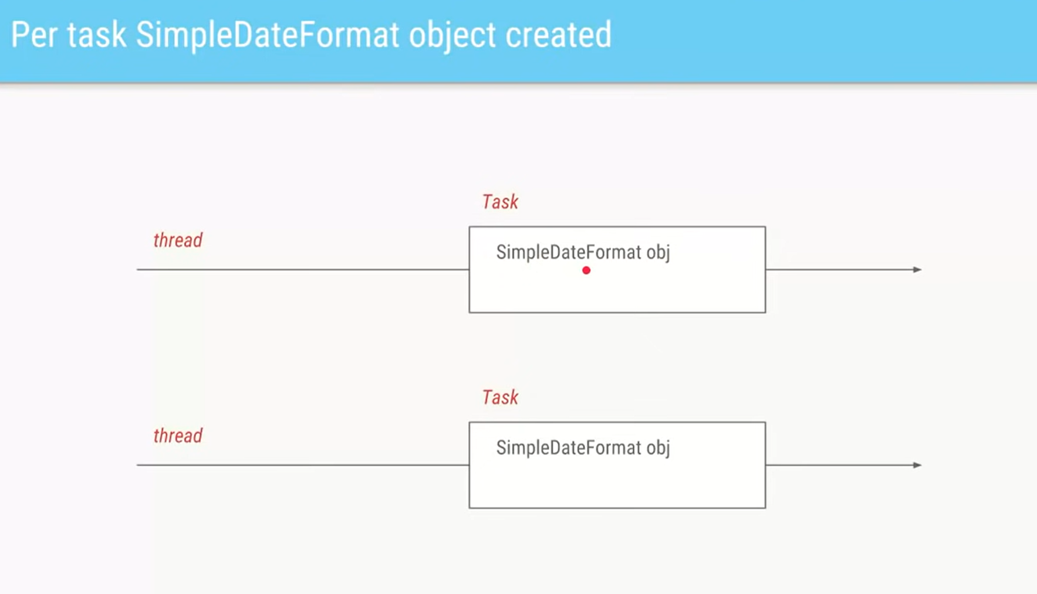

## Case 2: 10 Thread 10 Task

**package com.sumanshekhar.java.advance.multithreading.multithreading_by_defog.threadlocal;  
  
import java.text.SimpleDateFormat;  
import java.util.Date;  
import java.util.concurrent.ExecutorService;  
import java.util.concurrent.Executors;  
  
public class UserService {  
  
 static ExecutorService executorServicePool = Executors.newFixedThreadPool(10);  
  
 public static void main(String[] args) throws InterruptedException {  
  
  
  
  
 for (int i = 0; i < 10; i++) {  
 int finalI = i;  
 new Thread(() -> {  
 String s = new UserService().birthDate(finalI);// TODO final investigation  
 System.out.println(Thread.currentThread() + s);  
 }).start();  
 }  
  
  
 Thread.sleep(1000);  
 }  
  
 public String birthDate(int userId) {  
 SimpleDateFormat formatter = new SimpleDateFormat("dd/MM/yyyy HH:mm:ss");  
 Date date = new Date();  
 return userId + " ==> " + formatter.format(date);  
 }  
}**

We are creating 10 threads and all are running their own runnable tasks and all of them will create their own DateFormat objects.

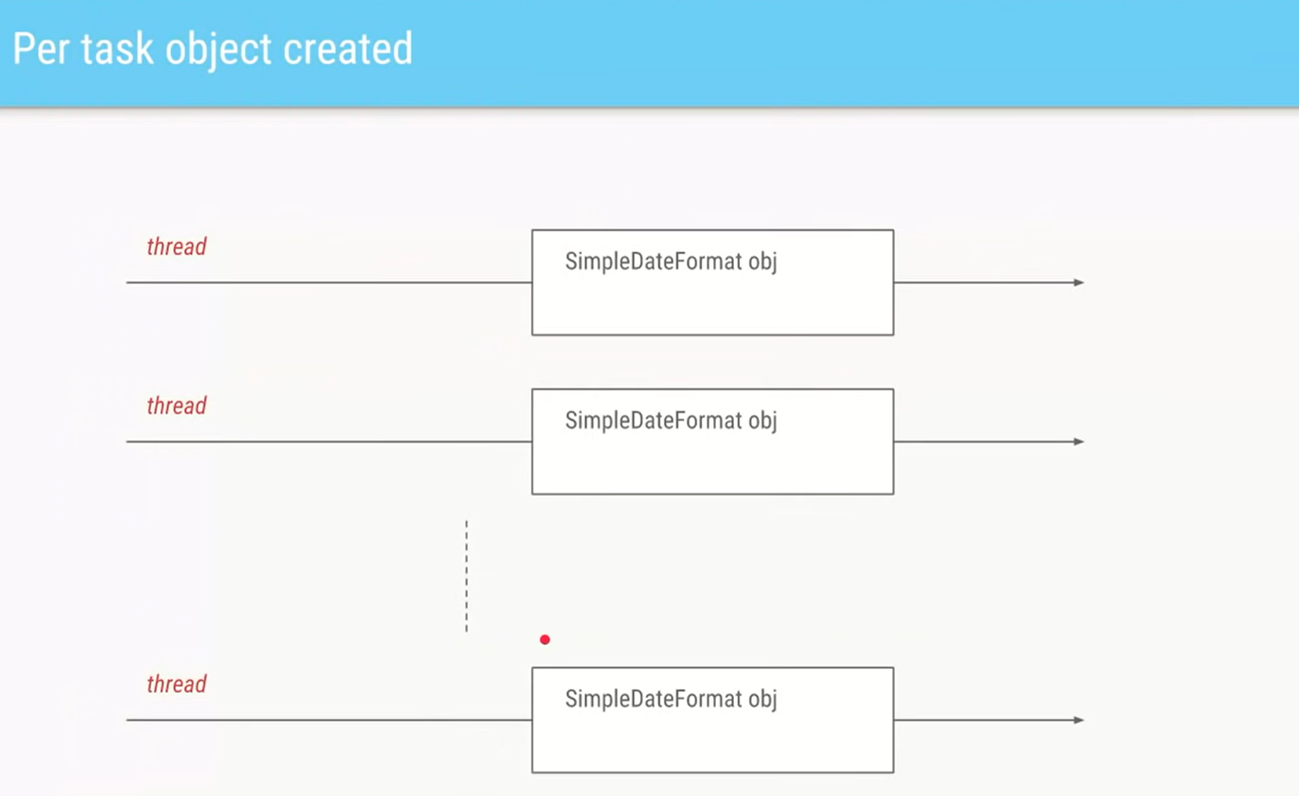

## Case 3: 10 Thread 1000 Task

Now If we want to do get the birthDate() for 1000 users, So its impractical to create 1000 threads, So we will have a thread pool of 10 threads and 1000 tasks.

|  |
| --- |
| **package** com.sumanshekhar.java.advance.multithreading.multithreading_by_defog.threadlocal;  **import** java.text.SimpleDateFormat; **import** java.util.Date; **import** java.util.concurrent.ExecutorService; **import** java.util.concurrent.Executors;  **public class** UserService {   **static** ExecutorService executorServicePool = Executors.newFixedThreadPool(10);   **public static void** main(String[] args) **throws** InterruptedException {  /* new Thread(() -> {  String s = new UserService().birthDate(2);  System.out.println(Thread.currentThread() + s);  }).start();*/   /* for (int i = 0; i < 10; i++) {  int finalI = i;  new Thread(() -> {  String s = new UserService().birthDate(finalI);// **TODO final investigation**  System.out.println(Thread.currentThread() + s);  }).start();  }*/   // Submitting 1000 task of 1000 user id to pool of 10 thread  **for** (**int** i = 0; i < 1000; i++) {  **int** finalI = i;  executorServicePool.submit(() -> {  String s = **new** UserService().birthDate(finalI);  System.out.println(Thread.currentThread() + s);  });  }    Thread.sleep(1000);  }   **public** String birthDate(**int** userId) {  SimpleDateFormat formatter = **new** SimpleDateFormat("dd/MM/yyyy HH:mm:ss");  Date date = **new** Date(); // System.out.println(formatter.format(date));  **return** userId + " ==> " + formatter.format(date);  } } |

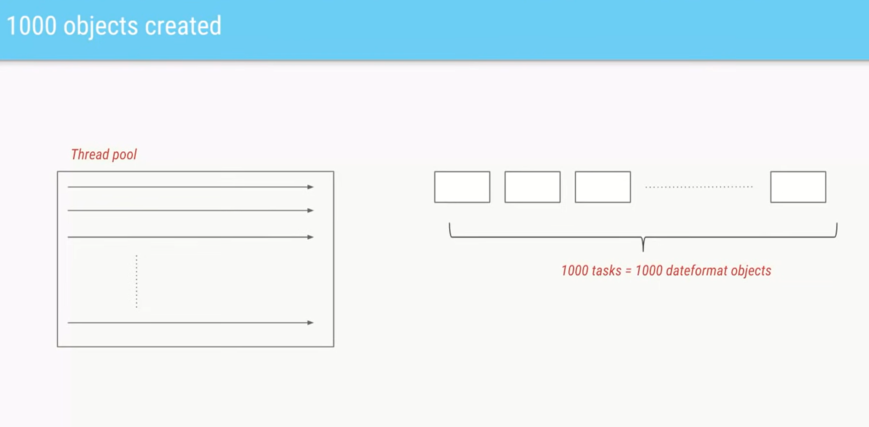

But still there are 1000 DateFormat object.

## Case 3.1: 10 Thread 1000 Task but one global DateFormat object

|  |
| --- |
| **package** com.sumanshekhar.java.advance.multithreading.multithreading_by_defog.threadlocal;  **import** java.text.SimpleDateFormat; **import** java.util.Date; **import** java.util.concurrent.ExecutorService; **import** java.util.concurrent.Executors;  **public class** UserService {   **private static** ExecutorService executorServicePool = Executors.newFixedThreadPool(10);  **private static** SimpleDateFormat formatter = **new** SimpleDateFormat("dd/MM/yyyy HH:mm:ss");   **public static void** main(String[] args) **throws** InterruptedException {  /* new Thread(() -> {  String s = new UserService().birthDate(2);  System.out.println(Thread.currentThread() + s);  }).start();*/   /* for (int i = 0; i < 10; i++) {  int finalI = i;  new Thread(() -> {  String s = new UserService().birthDate(finalI);// **TODO final investigation**  System.out.println(Thread.currentThread() + s);  }).start();  }*/   // Submitting 1000 task of 1000 user id to pool of 10 thread  **for** (**int** i = 0; i < 1000; i++) {  **int** finalI = i;  executorServicePool.submit(() -> {  String s = **new** UserService().birthDate(finalI);  System.out.println(Thread.currentThread() + s);  });  }   Thread.sleep(1000);  }   **public** String birthDate(**int** userId) { // SimpleDateFormat formatter = new SimpleDateFormat("dd/MM/yyyy HH:mm:ss");  Date date = **new** Date(); // System.out.println(formatter.format(date));  **return** userId + " ==> " + formatter.format(date);  } } |

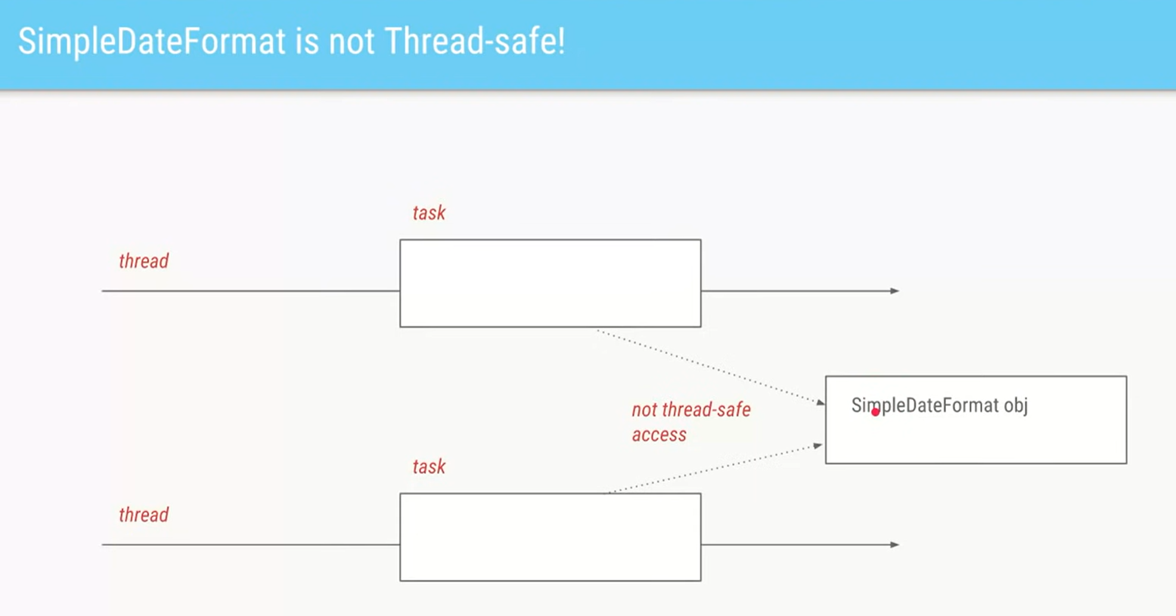

The issue here is this global object is not a thread safe, so if 2 or more threads try to access this at the same time, it can have data integrity issues. We can use **locks** to provide atomic access.

So, it needs a kind of synchronization, but our class and program will slow down a lot.

## Case⭐ 3.2.0: 10 Thread 1000 Task but using a ThreadLocal

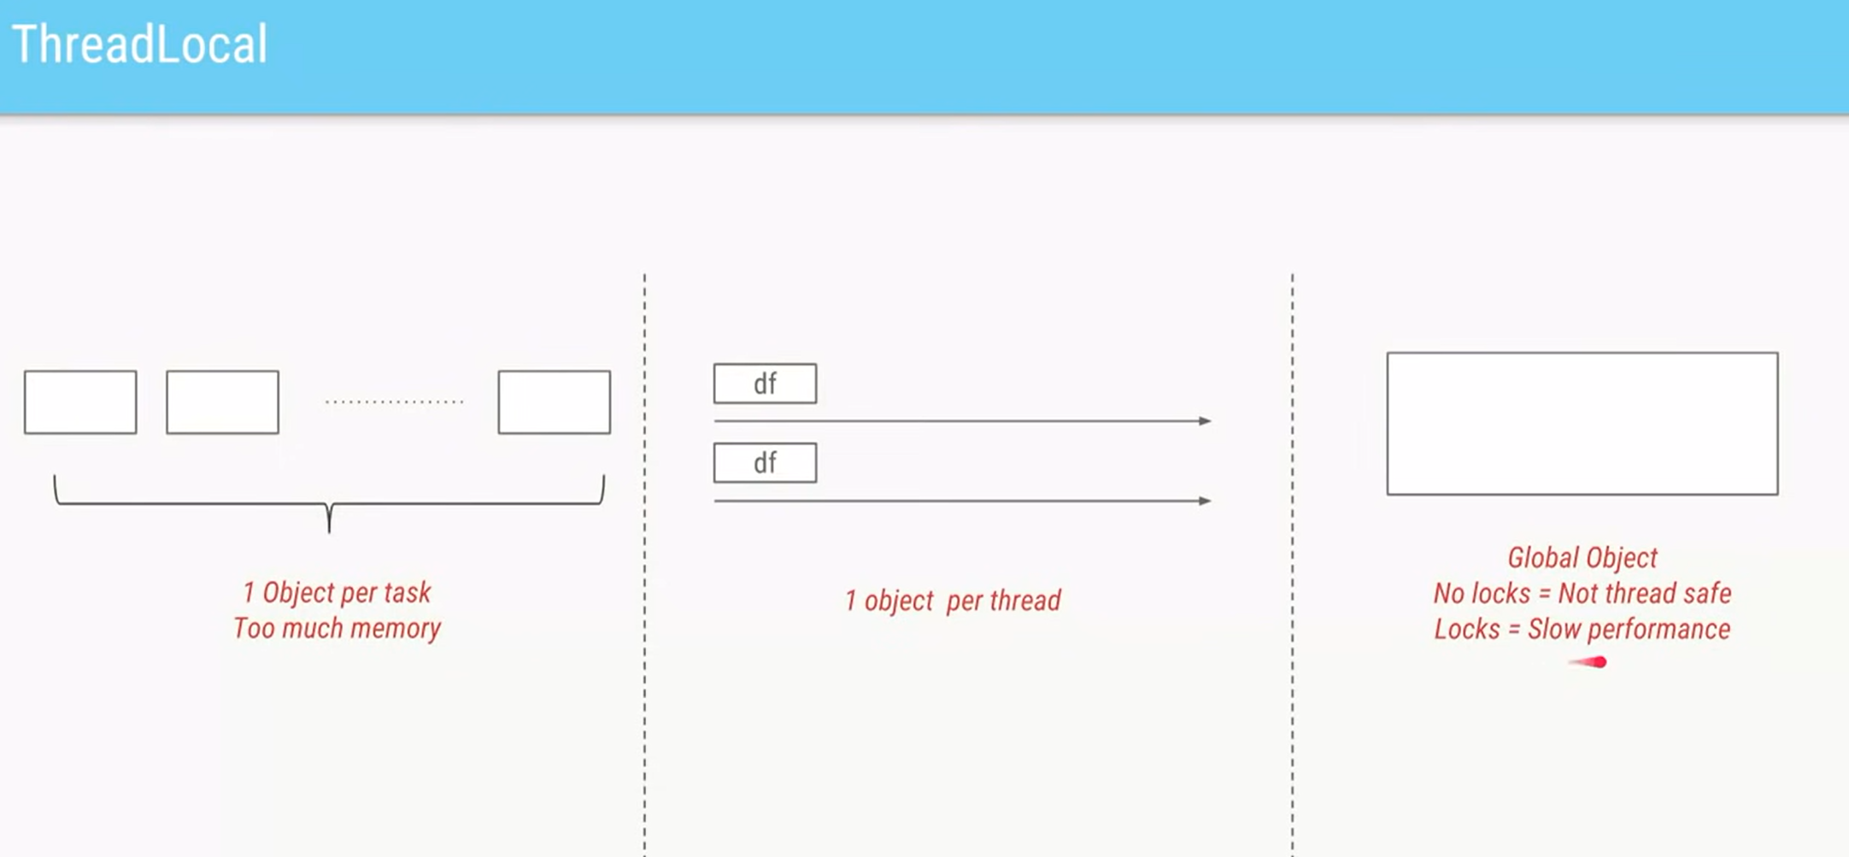

So, neither we want 1 Object per task, neither we want a single global synchronized object with low performance.

So, we can achieve an optimization in which Every thread will have its own specific objects/variable thus the name comes, **ThreadLocal**

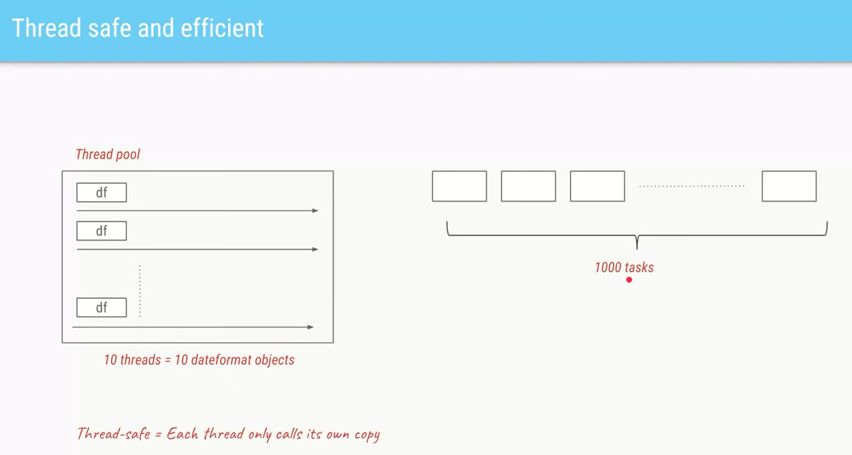

So, these 10 threads will have its own specific copy of ThreadLocal object and these number will not change during the entire run.

So, we get few benefits here

Theres is no synchronization issue and inherently it becomes a thread safe environment thus not hampering the performance.

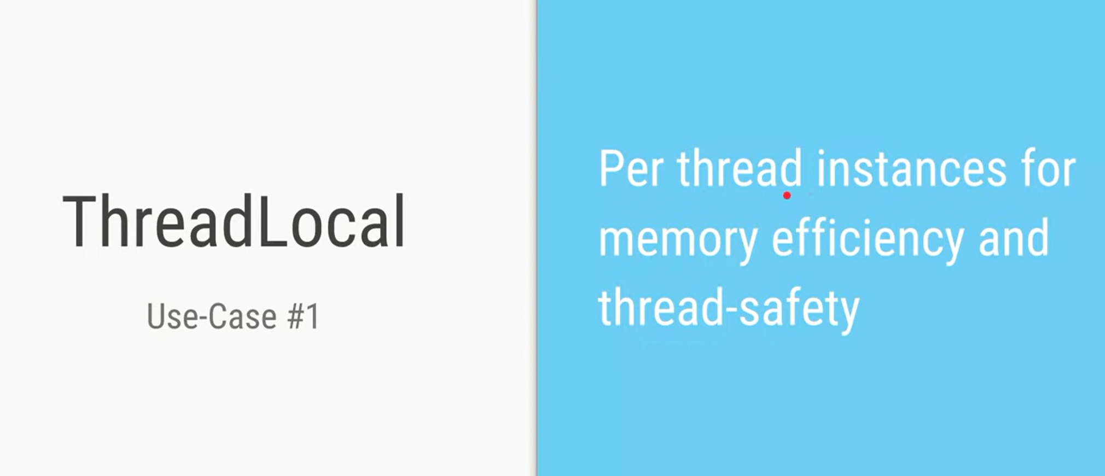

We can create a ThreadLocal object as a static variable extending it.

For the get(), Each thread who is calling it will have its own copy.

Or we can simply use the factory method with Lambda

ThreadLocal.withInitial(() ->)

**UserServiceOptimized.java**

|  |
| --- |
| package com.sumanshekhar.java.advance.multithreading.multithreading_by_defog.threadlocal;  import java.text.SimpleDateFormat; import java.util.Date; import java.util.concurrent.ExecutorService; import java.util.concurrent.Executors;  public class UserServiceOptimized {   private static ExecutorService *executorServicePool* = Executors.*newFixedThreadPool*(10); *// private static SimpleDateFormat formatter = new SimpleDateFormat("dd/MM/yyyy HH:mm:ss");* public static void main(String[] args) throws InterruptedException {   for (int i = 0; i < 1000; i++) {  int finalI = i;  *executorServicePool*.submit(() -> {  String s = new UserServiceOptimized().birthDate(finalI);  System.*out*.println(Thread.*currentThread*() + s);  });  }  Thread.*sleep*(1000);  *executorServicePool*.shutdown();  }   public String birthDate(int userId) {  final SimpleDateFormat formatter = ThreadSafeFormatter.*dateFormatter*.get();  Date date = new Date();  return userId + " ==> " + formatter.format(date);  }   }  class ThreadSafeFormatter {  *// Static declarations in inner classes are not supported at language level '8', it is in JDK 16* public static ThreadLocal<SimpleDateFormat> *dateFormatter* = new ThreadLocal<SimpleDateFormat>() {   @Override  protected SimpleDateFormat initialValue() {  return new SimpleDateFormat("dd/MM/yyyy HH:mm:ss"); *// return super.initialValue();* }   @Override  public SimpleDateFormat get() {  return super.get();  }  };   *// with Initial is a factory method for creating thread Local // we will pass the Lambda saying this is the initial value I want it for Thread Local* public static ThreadLocal<SimpleDateFormat> *dateFormatter2* = ThreadLocal.*withInitial*(() -> new SimpleDateFormat("dd/MM/yyyy HH:mm:ss")); } |

## Case⭐ 3.2.1: ThreadLocal in WebServices

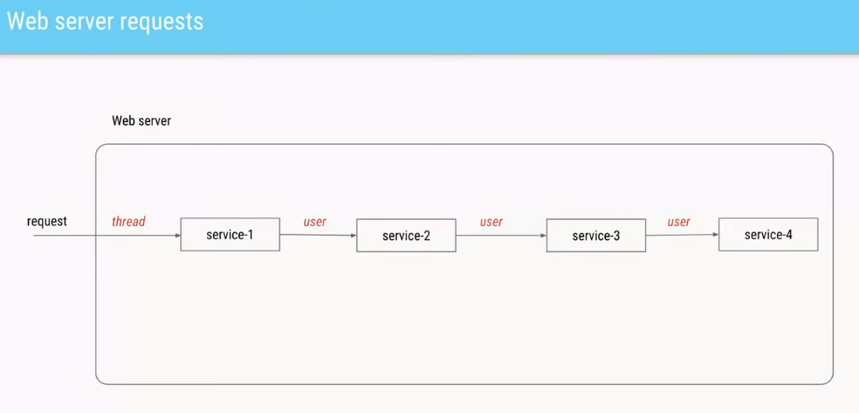

Let us say we have a web server,

Whenever there is a request, there is a thread assigned to process the request.

This request goes via 4 services and all these 4 services need to know which actual user has made the request. So, each service will pass the user for every subsequent service.

### Solution 1 Using Synchronized Map

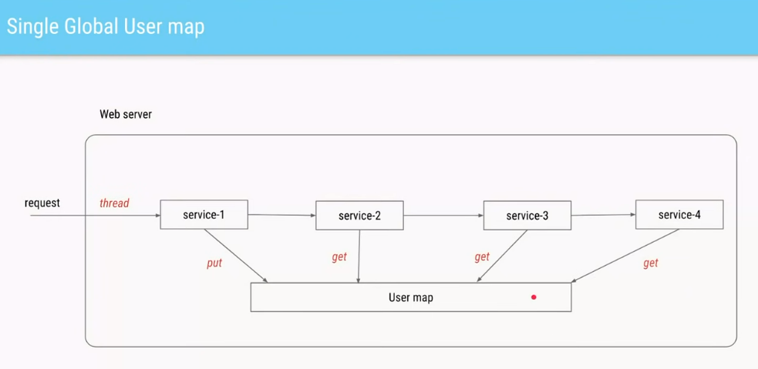

We can have a map and all the subsequent service can access via get().

But it needs synchronization.

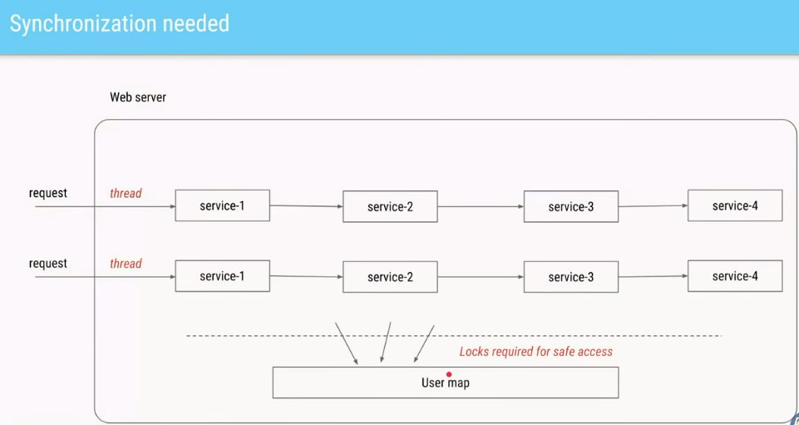

In Multithreaded env if all the thread are accessing this Global shared Map, then it need synchronization for thread safety.

We can use locks or concurrent HashMap.

### Solution 2 Using ThreadLocal

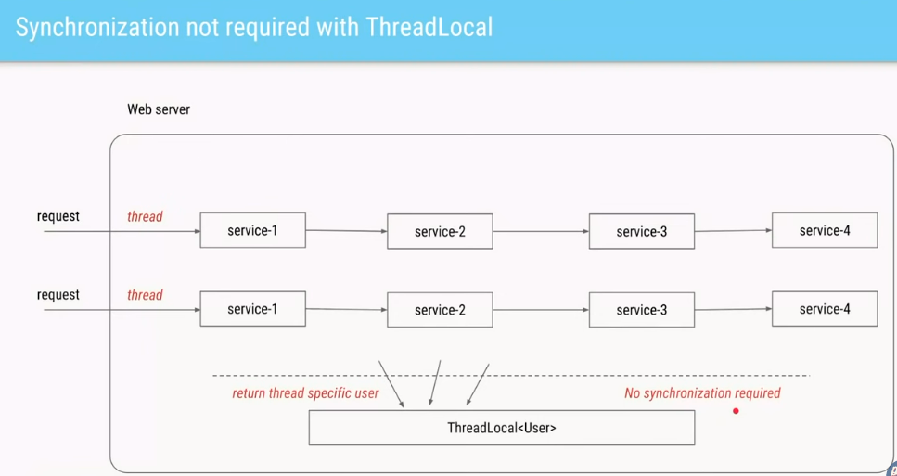

Here by using the thread local we can avoid synchronization and so enhance performance and no need to pass the user from service to service.

All the classes involved in the flow for a particular thread should use the same context

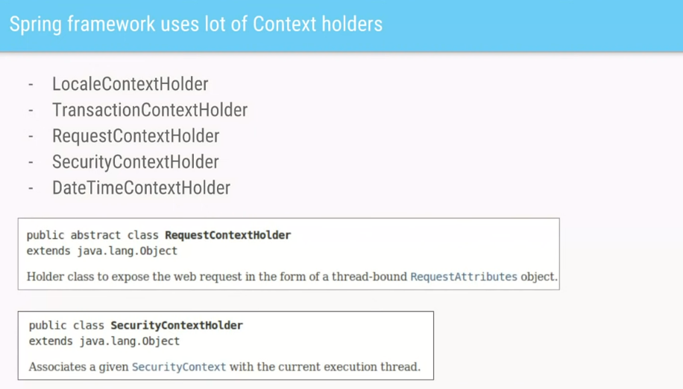

In Spring uses this ThreadLocal and ContextHolder in Many for its classes.

RequestConetxtHolder to store any of the request Holders throughout the scope of the request and a request in Spring is of course handled by SingleThread.

Anytime in the flow it is able to give the Request attribute.

Spring also uses to manage Transaction.

if we have stored something per request, we need to ensure the cleaning once the processing of that thing is over.

|  |
| --- |
| package com.sumanshekhar.java.advance.multithreading.multithreading_by_defog.threadlocal;  import com.sumanshekhar.java.advance.multithreading.multithreading_by_defog.parallelism.User;  public class WebServiceOptimized {   }  class UserContextHolder {  public static ThreadLocal<User> *holder* = new ThreadLocal<User>();  }   class Service1 {*//Set it for current thread* private void process() {  User user = getUser();  *//set* UserContextHolder.*holder*.set(user);  }   private User getUser() {  return new User(1, 8998);  } }  class Service2 {  private void process() {  *//get* User user = UserContextHolder.*holder*.get();*//Get it for current Thread* } }  class Service3 {  private void process() {  *//get* User user = UserContextHolder.*holder*.get();  } }  class Service4 {  private void process() {  *//get* User user = UserContextHolder.*holder*.get();  *//cleanup* UserContextHolder.*holder*.remove();  } } |

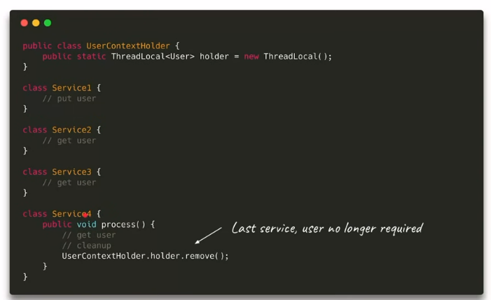

For our case, after Service4 we can do a clean-up.

## Use Case and Tips for ThreadLocal

### Use Cases

* Thread Confinement, using one object per thread which guarantees Thread Safety
* Per thread object enhances performance
* Per thread Context.

### Tips

* Clean-up once out of scope.
* Use Local variable, if possible, to avoid ThreadLocal
* Delegate to frameworks like various ContextHolders in Spring.